APPENDIX 1

Hong Kong / Mainland Gift Fulfillment Service
New Gift Sets for Lunar New Year 2006

Gift Sets provided by China Post (Made in China)
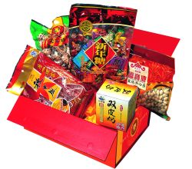 | Mini Gift Set  Product Code: NYC1 (Delivery to mainland only)  Retail Price: HK$288  Item List:  - Steamed Milk Pudding(125g)  - Candies (600g)  - Pistachios (330g)  - Preserved Meat Sausages (475g)  - Dried Mushrooms (400g)
Assorted Gift Set  Product Code: NYC2 (Delivery to mainland only)  Retail Price: HK$328  Item List:  - Plum Tea (300g)  - Coffee (325g)  - Fried Whitebaits (250g)  - Preserved Watermelon Seeds (500g)  - Pistachios (330g)  - Walnut Pastry (450g) |  | 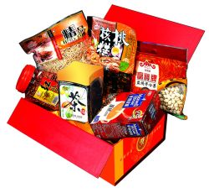
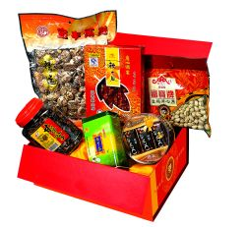 | Deluxe Gift Set  Product Code: NYC3 (Delivery to mainland only)  Retail Price: HK$368  Item List:  - Chinese Tea (180g)  - Chocolate (304g)  - Preserved Watermelon Seeds (500g)  - Pistachios (330g)  - Preserved Meat Sausage (475g)  - Dried Mushrooms (400g)
Splendid Gift Set  Product Code: NYC4 (Delivery to mainland only)  Retail Price: HK$398  Item List:  - Cigarettes (10 packs)  - Chinese Tea (180g)  - Preserved Watermelon Seeds (500g)  - Roasted Cashews (380g)  - Walnut Pastry (450g)  - Abalone Slice Pastry (240g)  - Preserved Meat Sausage (475g)  - Dried Mushrooms (245g) |  |  | 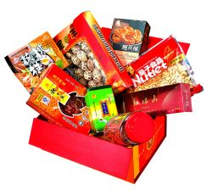

Gift Sets provided by Wing Wah Food Manufactory Limited (Supply from Hong Kong)

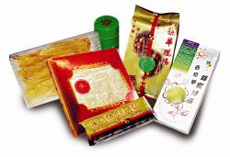 | Supreme Gift Box  Product Code: NYC5 (Delivery to mainland)  NYHK5 (Delivery in HK)  Retail Price: HK$688  Item List:  - Jasmine Tea (170g)  - Honey & Green Tea Cookies (10 pieces)  - Candies (8 pieces)  - Preserved Meat Sausages (303g)  - Dried Fish Maw (150g)  - Dried Shark Fin (150g)
Exquisite Gift Box  Product Code: NYC6 (Delivery to mainland)  NYHK6 (Delivery in HK)  Retail Price: HK$688  Item List:  - Jasmine Tea (170g)  - Cookies (24 pieces)  - Egg Roll (450g)  - Bird’s Nest Jelly Candy (200g)  - Candies (8 pieces)  - Dried Fish Maw (150g)  - Dried Scallop (150g) |  | 