Appendix 1

“Valentine Local CouierPost” Pre-paid Envelopes
(Available at all post offices from 1 to 13 February 2006)
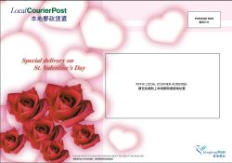

Price : $35



Front
Back

Greeting Card (accompanying free gift)

Product: “Valentine Local CourierPost” prepaid envelope
Price: $35 (including the local courier delivery charge for contents below 1 kg)
Description: The prepaid envelope is specially designed for delivery on Valentine’s Day. A Greeting Card will be given free-of-charge with each “Valentine Local CourierPost” prepaid envelope. Guaranteed delivery on 14 February 2006.
Appendix 2

PostShop Valentine’s Day Gift Sets
(Available for mail order at all post offices and ShopThruPost (www.shopthurpost.hk)
from 1 to 9 February 2006)

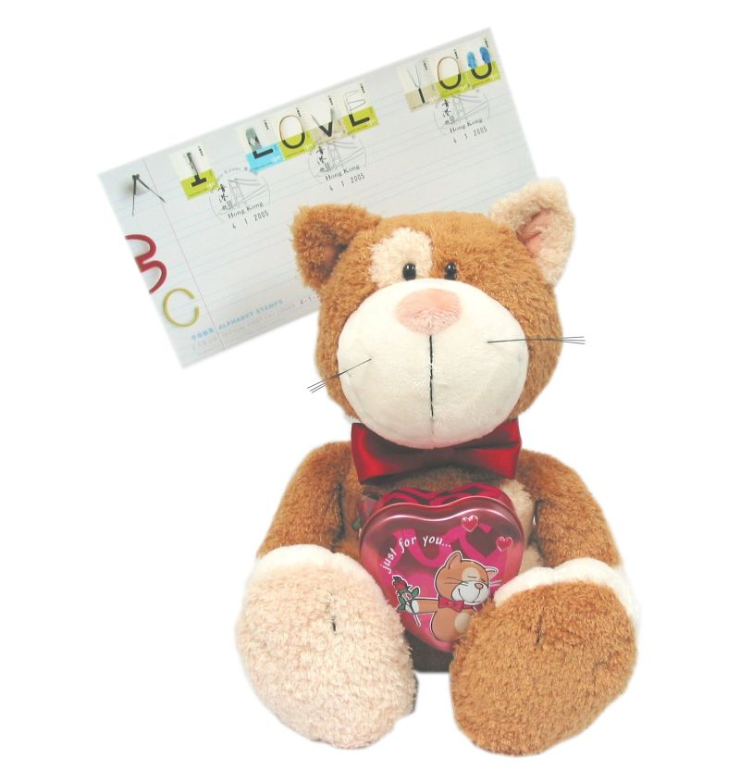

“Cats in Love” Gift Set
(Price : $268)

Product: “Cats in Love” Gift Set

Price: $268 (including the Local CourierPost delivery charge)

Description: The Gift Set contains a cuddly 35cm-tall Tomcat with magnetised paws holding a heart-shaped container of bath confetti together with the Alphabet Stamp Souvenir Cover affixed with “I Love You” gummed stamps. The stamps will be cancelled with a 14 February 2006 Philatelic Bureau postmark.

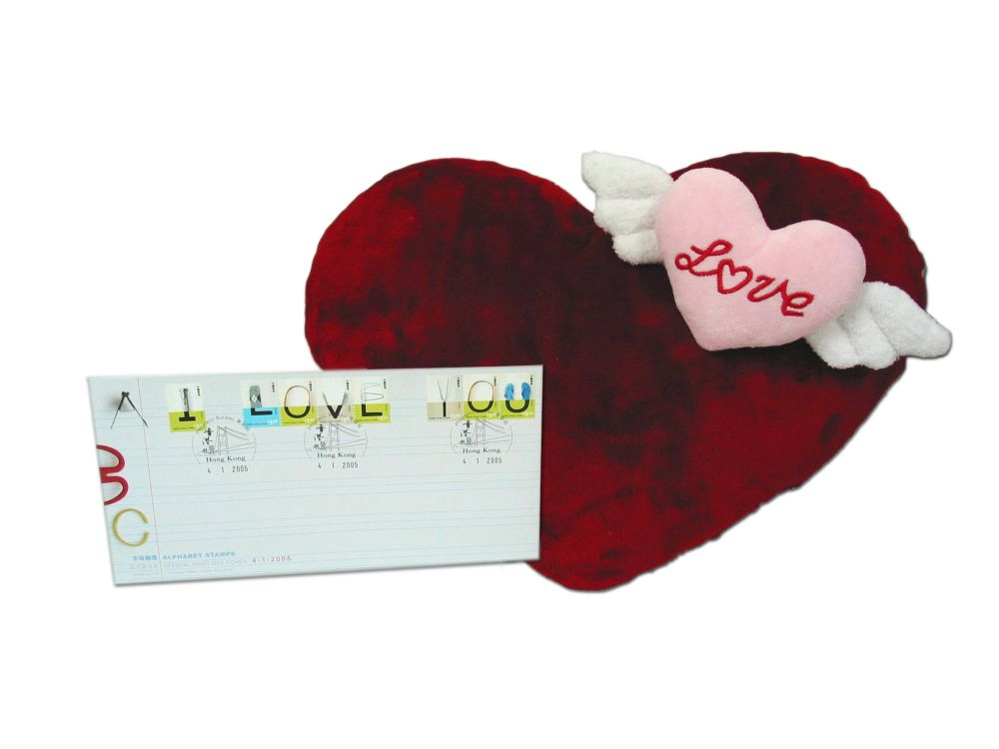

“Sweetheart in Mind” Gift Set
(Price : $168)

Product: “Sweetheart in Mind” Gift Set

Price: $168 (including the Local CourierPost delivery charge)

Description: The Gift Set contains a red velvet heart-shaped cushion with a winged pink heart clasp, together with an Alphabet Stamp Souvenir Cover affixed with “I Love You” gummed stamps. The stamps will be cancelled with a 14 February 2006 Philatelic Bureau postmark.

Appendix 2

Japanese Premium Chocolate and Sweets Gift Sets
(Available at ShopThruPost (www.shopthrupost.hk) from 1 February, 2006)

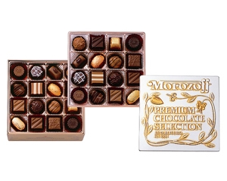

Japanese Premium Chocolate Gift Set
“Aroma of Sweeties”
(Price : $320)

Product: Japanese Premium Chocolate Gift Set – “Aroma of Sweeties”

Price: $320 (including Speedpost postage for product sent from Japan)

Description: “Aroma of Sweeties” is a premium selection of luxurious chocolates with a western liqueur-like taste in deluxe packaging, sent directly from Hyougo Prefecture in Western Japan.

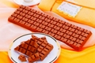

Japanese Premium Chocolate Gift Set
“Bulk of Love”
(Price : $240)

Product: Japanese Premium Chocolate Gift Set – “Bulk of Love”

Price: $240 (including Speedpost postage for product sent from Japan)

Description: “Bulk of Love” is made from selected quality ingredients, including cacao, cocoa-butter and milk in a large piece of chocolate, specially made and delivered from Hokkaido in Northern Japan.

Japanese Premium Chocolate Gift Set
“Lovers’ Choice”
(Price : $240)
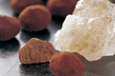
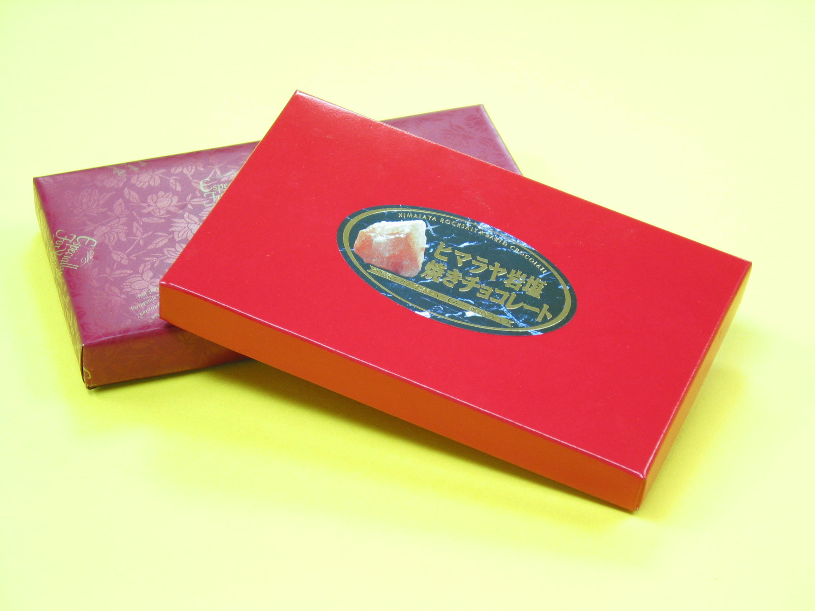

Product: Japanese Premium Chocolate Gift Set – “Lovers’ Choice”

Price: HK$240/ set of 2 boxes (including Speedpost postage for product sent from Japan)

Description: Every piece of chocolate in “Lovers’ Choice” is baked with rock salt for a specified time, creating a delicious and unique mild taste of sweetness.

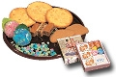

Japanese Cookies and Sweets Collection
“Tastes of Love”
(Price : $380)

Product: Japanese Cookies and Sweets Collection – “Tastes of Love”

Price: $380 (including Speedpost postage for product sent from Japan)

Description: Various cookies and sweets made from a traditional recipe with selected ingredients, delivering directly from Kanagawa Prefecture in Japan.

