APPENDIX 1

Hong Kong/ Mainland Gift Fulfillment Service
New Occasional Gift Sets

Cakes
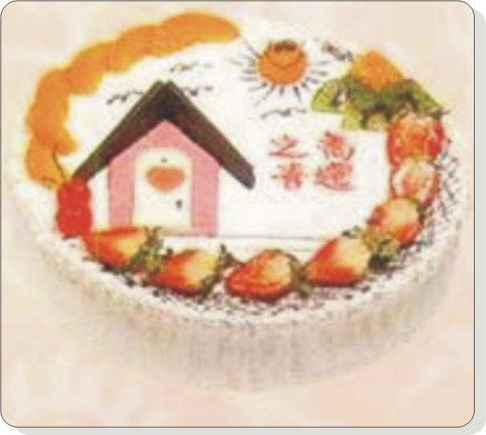 | Housewarming Cake (2 Pounds)  Product Code: C-064  Retail Price: HK$298  Product Details:  - 2-pound fresh fruit cake with “Housewarming” message on it
Lover's Cake (3 Pounds)  Product Code: C-018  Retail Price: HK$398  Product Details:  - 3-pound square shaped cake with "I LOVE YOU" and “Happy Birthday” written on it |  | 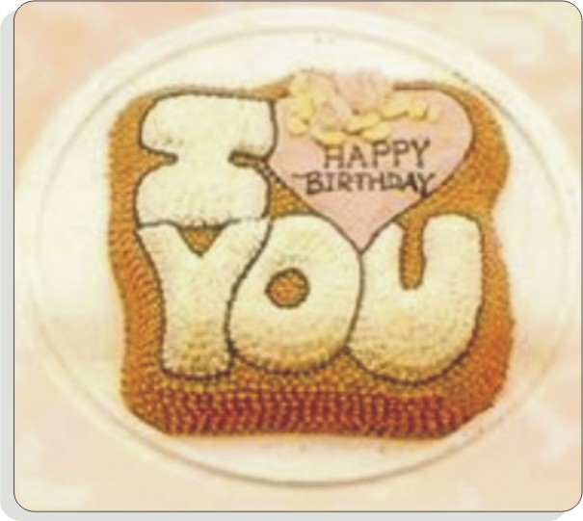

Flower Baskets
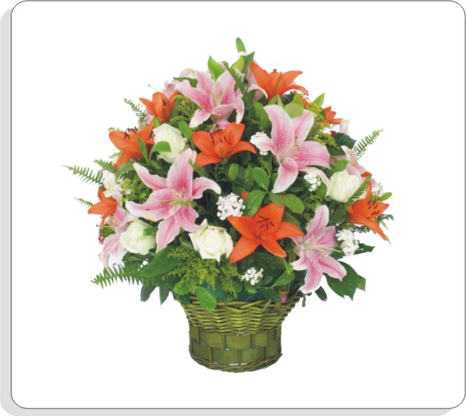 | Splendid Tomorrow  Product Code: HL-097  Retail Price: HK$668  Product Details:  - 10 single stem pink lilies, 10 mini golden lilies and 6 white roses with complementary greenery
Fire Dance  Product Code: HS-107  Retail Price: HK$1,128  Product Details:  - 6 birds-of-paradise, 30 anthuriums, and 6 orchids accented by greenery  - With glass vase |  | 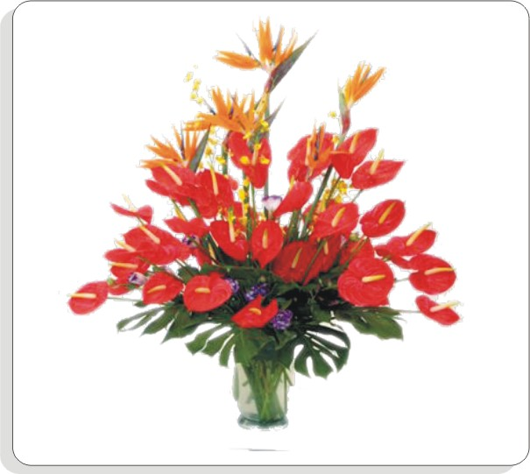

Bouquets
Love Series
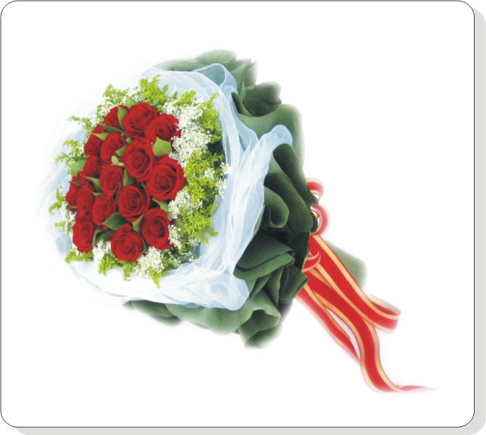 | Thinking of You  Product Code: AQ-064  Retail Price: HK$368  Product Details:  - 16 red roses, baby’s breath accented by greenery  - Wrapped in mesh and wrinkle paper
Truth of Romance  Product Code: AQ-070  Retail Price: HK$988  Product Details:  - 99 pink roses wrapped in pink wrinkle paper |  | 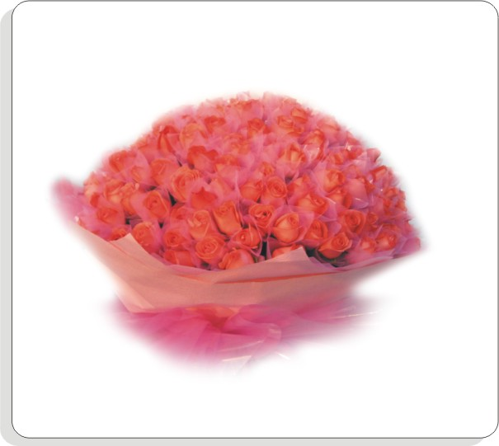
Occasion Series
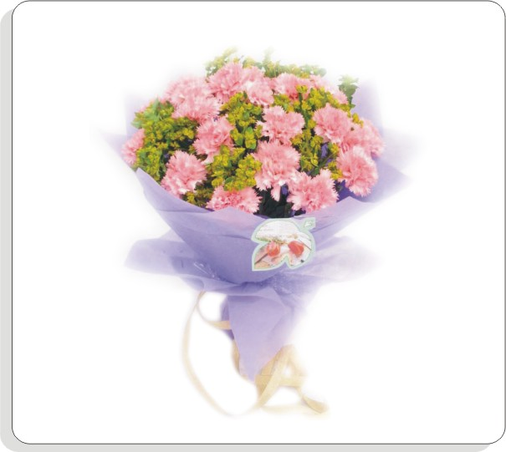 | Truly in Love  Product Code: AQ-023  Retail Price: HK$288  Product Details:  - 22 pink carnations with golden leaf  - Wrapped in coloured paper with gold ribbons
Heartfelt Blessing  Product Code: AQ-171  Retail Price: HK$328  Product Details:  - 11 yellow roses accented by greenery and small flowers  - Wrapped in wrinkle paper |  |  | 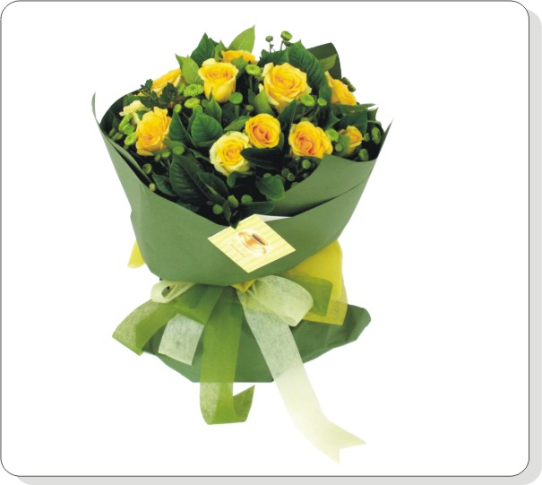
Bouquets
Sympathy Series
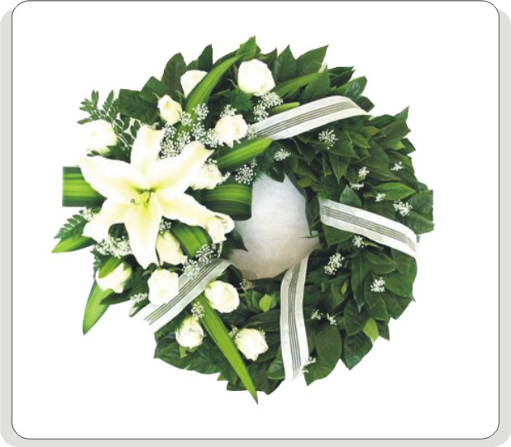 | Sincere Mourning  Product Code: AQ-141  Retail Price: HK$561  Product Details:  - 1 white lily, 9 white roses with greenery  - Decorated with white ribbons
Unlimited Mourning  Product Code: AQ-144  Retail Price: HK$1,261  Product Details:  - 99 white roses and 2 lilies with greenery |  | 