APPENDIX 1

Hong Kong / Mainland Gift Fulfillment Service
New Mooncake Gift Sets for Mid-Autumn Festival 2006

“Kee Wah” Mooncake Gift Sets (Made in Hong Kong)

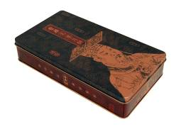 |  | Mini Golden Lotus Seed Paste Mooncakes with Half Yolk  Product Code : KWCN1(To the Mainland)  KWHK1(To Hong Kong)  Retail Price : $198 (To the Mainland)  $168 (To Hong Kong)  Item List:  • 8 pieces per box
Mini White Lotus Seed Paste Mooncakes with  Half Yolk  Product Code : KWCN2 (To the Mainland)  KWHK2 (To Hong Kong)  Retail Price : $198 (To the Mainland)  $168 (To Hong Kong)  Item List:  • 8 pieces per box |  |  | 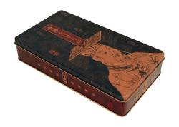
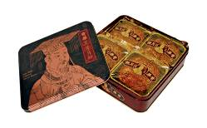 |  | Golden Lotus Seed Paste Mooncakes with Two Yolks  Product Code: KWCN3 (To the Mainland)  KWHK3 (To Hong Kong)  Retail Price : $268 (To the Mainland)  $228 (To Hong Kong)  Item List:  • 4 pieces per box
White Lotus Seed Paste Mooncakes with Two Yolks  Product Code: KWCN4 (To the Mainland)  KWHK4 (To Hong Kong)  Retail Price : $268 (To the Mainland)  $228 (To Hong Kong)  Item List:  • 4 pieces per box |  |  | 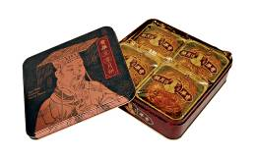
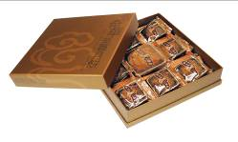 | Assorted Gift Box  Product Code : KWCN5 (To the Mainland)  KWHK5 (To Hong Kong)  Retail Price : $268 (To the Mainland)  $228 (To Hong Kong)  Item List:  - Golden Lotus Seed Paste Mooncake with Two Yolks x 1  - Mini White Lotus Seed Paste Mooncake with Half Yolk x 1  - Mini Golden Lotus Seed Paste Mooncake with Half Yolk x 1  - Mini Chinese Ham Mooncake x 1  - Mini Pineapple Paste Mooncake with Half Yolk x 1  - Mini Black Date Paste Mooncake x 1  - Mini Winter-Melon Paste Mooncake x 1  - Mini Green Bean Paste Mooncake with Mixed Yolk x 1  - Mini Red Bean Paste Mooncake with Half Yolk x 1
Royal Gift Box  Product Code : KWCN6 (To the Mainland)  KWHK6 (To Hong Kong)  Retail Price : $768 (To the Mainland)  $668 (To Hong Kong)  Item List:  • Golden Lotus Seed Paste Mooncake with  Four Yolks x 4  - Golden Lotus Seed Paste Mooncake with  Two Yolks x 4  - Mini Golden Lotus Seed Paste Mooncake with  Half Yolk x 9 |  |  | 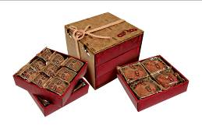

“Wing Wah” Mooncake Gift Sets (Made in Hong Kong)

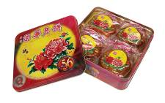 | Lotus Seed Paste Mooncake with Two Yolks  Product Code : WHCN7 (To the Mainland)  WHHK7(To Hong Kong)  Retail Price : $288 (To the Mainland)  $238 (To Hong Kong)  Item List:  - 4 pieces per box
White Lotus Seed Paste Mooncake with Two Yolks  Product Code : WHCN8 (To the Mainland)  WHHK8 (To Hong Kong)  Retail Price : $288 (To the Mainland)  $238 (To Hong Kong)  Item List:  • 4 pieces per box |  |  | 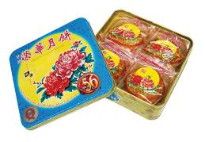
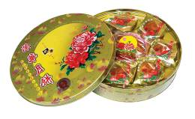 |  | Mini Assorted Mooncakes  Product Code : WHCN9 (To the Mainland)  WHHK9 (To Hong Kong)  Retail Price : $388 (To the Mainland)  $288 (To Hong Kong)  Item List:  - White Lotus Seed Paste Mooncake with  Three Yolks x 1  - Mini White Lotus Seed Paste Mooncake with Half Yolk x 7

“Yu Xiang Yue” Mooncake Gift Sets (Exclusively distributed by China Post, made in China)
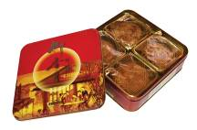 | Mixed Gift Pack  Product Code : YHCN10 (To the Mainland)  Retail Price : HK$168  Item List:  • White Lotus Seed Paste Mooncake with  Yolk x 1 (180g)  • Golden Lotus Seed Paste Mooncake with  Yolk x 1 (180g)  - Pineapple Paste Mooncake x 1 (180g)  - Mixed Nuts Mooncake x1 (180g)  • Mixed Nuts Mooncake x 1
Superior Gift Pack  Product Code : YHCN11 (To the Mainland)  Retail Price : HK$188  Item List:  - White Lotus Seed Paste Mooncake with  Two Yolks x 4 (180g) |  | 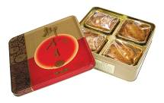
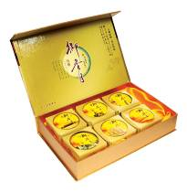 | Deluxe Gift Pack  Product Code : YHCN12 (To the Mainland)  Retail Price : HK$228  Item List:  - White Lotus Seed Paste Mooncake with  Yolk x 1 (120g)  - Golden Lotus Seed Paste Mooncake with  Yolk x 1 (120g)  - Pineapple Paste Mooncake x 1 (120g)  - Mixed Nuts Mooncake x 1 (120g)  - Black Date Paste Mooncake x 1 (120g)  - Seaweed Paste Mooncake x 1 (120g)
Supreme Gift Pack  Product Code : YHCN13 (To the Mainland)  Retail Price : HK$268  Item List:  - White Lotus Seed Paste Mooncake with  Two Yolks x 1 (230g)  - Mini White Lotus Seed Paste Mooncake with  Half Yolk x 7 (100g) |  |  | 