於出入境管制站發出的通知標簽樣本

Specimen of Notification Label issued at Control Points

(1)
批 准 逗 留 至
Permitted to remain
until 12 Sep 2007

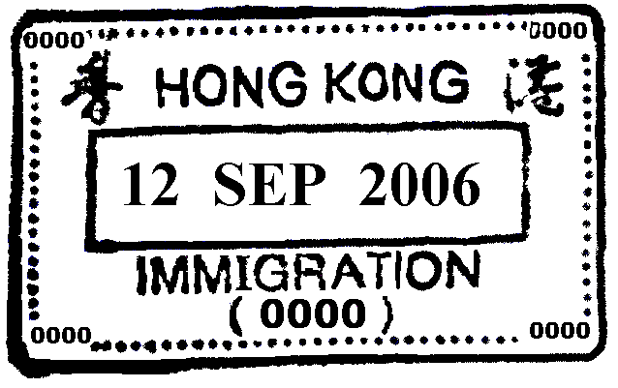

已施加於你的逗留期限及逗留條件(如有)，對於你在該逗留期限的有效期內再次入境時仍然適用，除非該逗留期限及逗留條件已期滿失效、或被撤銷、變更、縮短期限或因任何理由而變為無效。

The limit and condition(s) of stay, if any, imposed on you will, unless expired, cancelled, varied, curtailed or for whatever reason becomes invalid, apply to any subsequent landing in Hong Kong within the currency of the limit of stay.

(2)

僱傭工作 -批 准 逗 留 至
EMPLOYMENT - Permitted to remain until 12 Sep 2007

已施加於你的逗留期限及逗留條件(如有)，對於你在該逗留期限的有效期內再次入境時仍然適用，除非該逗留期限及逗留條件已期滿失效、或被撤銷、變更、縮短期限或因任何理由而變為無效。

The limit and condition(s) of stay, if any, imposed on you will, unless expired, cancelled, varied, curtailed or for whatever reason becomes invalid, apply to any subsequent landing in Hong Kong within the currency of the limit of stay.

於獲准延期逗留時發出的通知標籤樣本

Specimen of Notification Label issued upon Granting of Extension of Stay

香港入境事務處 | D 296276
IMMIGRATION HONG KONG | D 296276
XXXX-0000001-06(1) TWP-T
CHAN, TAI MAN
陳大文
輸入內地人才計劃
Admission Scheme for
Mainland Talents and Professionals
僱傭工作 - 獲准逗留期限延至 12-09-2007
EMPLOYMENT - Permission to remain
extended until 12-09-2007
為以下僱主工作
For employment with
ABC Company
未得入境事務處處長批准，不得轉換工作。
Change of employment without approval of
the Director of Immigration is not permitted.
已施加於你的逗留期限及逗留條件(如有)，對於你在該逗
留期限的有效期內再次入境時仍然適用，除非該逗留期
限及逗留條件已期滿失效、或被撤銷、變更、縮短期限
或因任何理由而變為無效。
The limit and condition(s) of stay, if any, imposed on
you will, unless expired, cancelled, varied, curtailed or
for whatever reason becomes invalid, apply to any
subsequent landing in Hong Kong within the currency
of the limit of stay.
經已繳費 Fee Paid HK$160.00 12-09-2006

於個別申請時發出的通知標籤樣本

Specimen of Notification Label issued upon Individual Application

香港入境事務處 | D 296276
IMMIGRATION HONG KONG | D 296276
XXXX-0000001-06(1) TWP-T
CHAN, TAI MAN
陳大文
輸入內地人才計劃
Admission Scheme for
Mainland Talents and Professionals
持證人在 01-01-2006 持
往來港澳通行証號碼W12345678扺達香港
The holder arrived Hong Kong on
01-01-2006 on strength of
EEP No. W12345678
並獲准以下列條件入境：
and was permitted to land on
the following conditions :
僱傭工作 - 批准逗留至 01-01-2007
EMPLOYMENT - Permitted to remain until 01-01-2007
為以下僱主工作
For employment with
ABC Company
未得入境事務處處長批准，不得轉換工作。
Change of employment without approval of
the Director of Immigration is not permitted.
已施加於你的逗留期限及逗留條件(如有)，對於你在該逗留
期限的有效期內再次入境時仍然適用，除非該逗留期限及
逗留條件已期滿失效、或被撤銷、變更、縮短期限或因任
何理由而變為無效。
The limit and condition(s) of stay, if any, imposed on you
will, unless expired, cancelled, varied,
curtailed or for whatever reason becomes invalid,
apply to any subsequent landing in Hong Kong
within the currency of the limit of stay.
免收費用 No fee 12-09-2006

