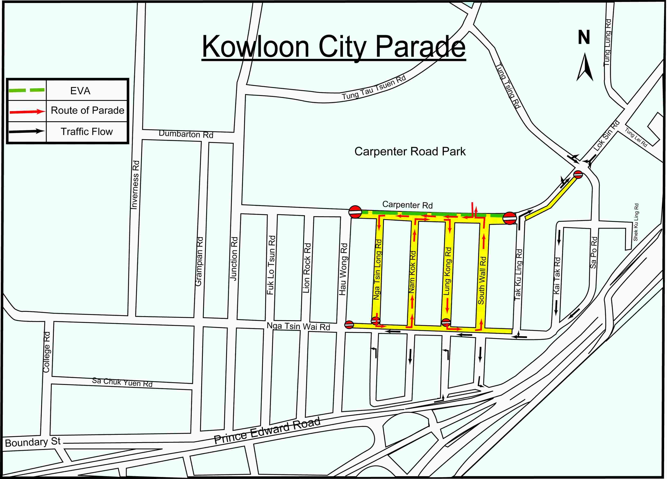
Road Closure Area during the
Kowloon City Parade on 2007-06-30

