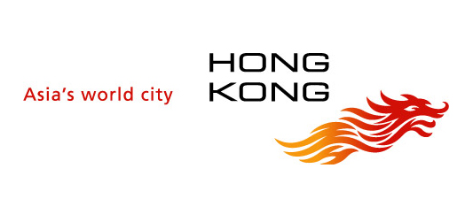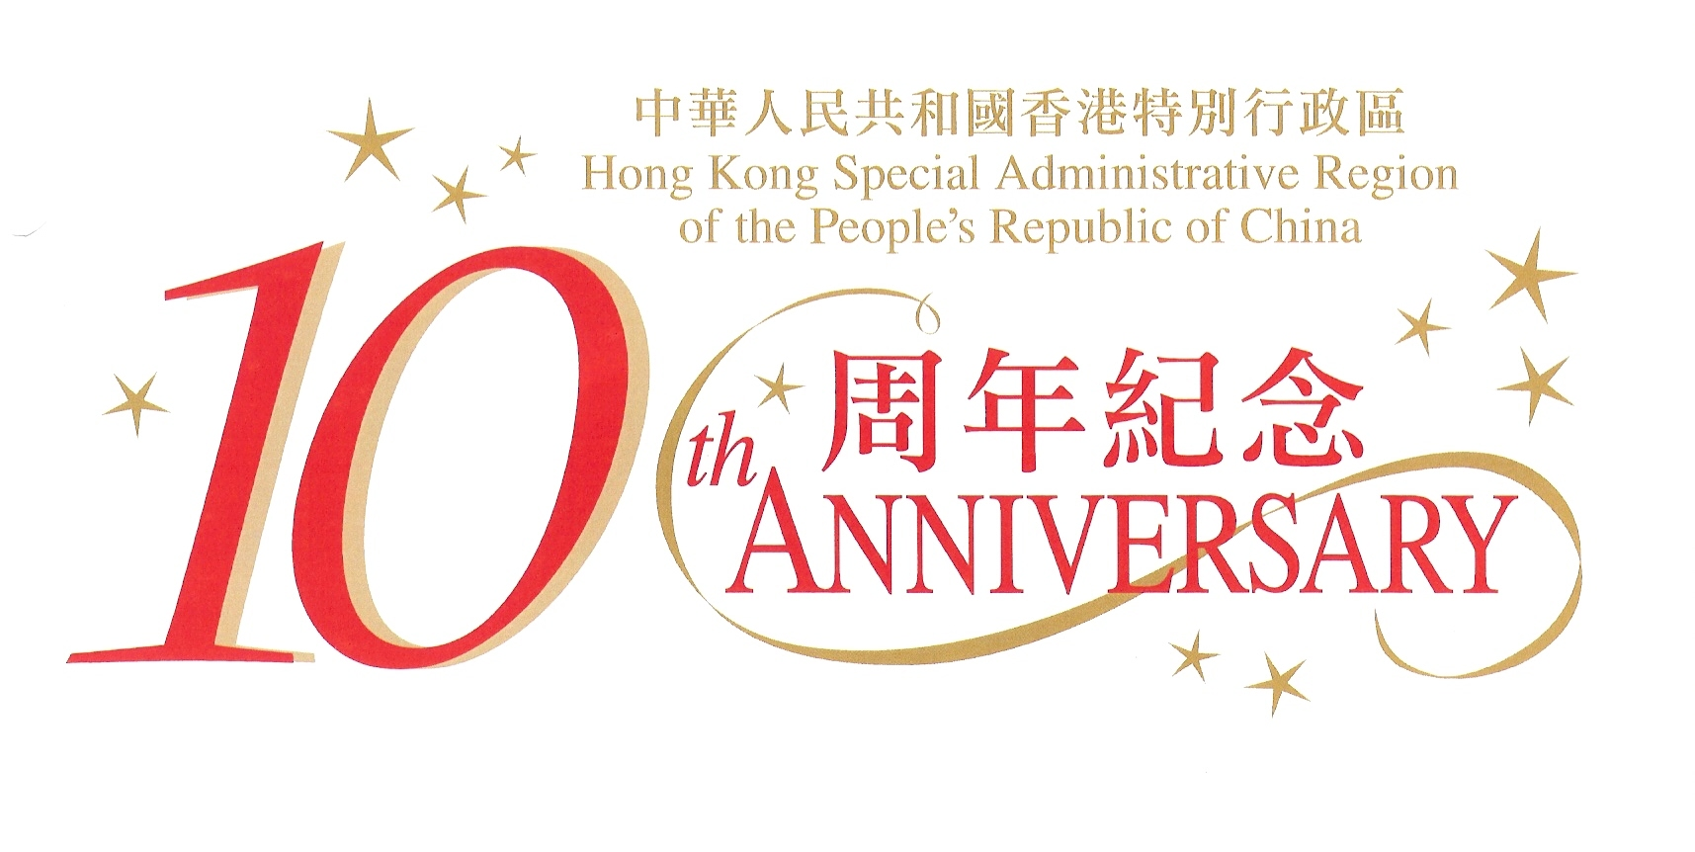

2007 marks the 10th anniversary of the establishment of the Hong Kong Special Administrative Region. In the coming months, the Hong Kong Economic and Trade Office in London will organise and support a series of events to promote and raise the profile of Hong Kong to celebrate the 10th anniversary.

Jun – Jul | ‘Made in Hong Kong’ Film Season  Cornerhouse, Manchester, UK (http://www.cornerhouse.org/film/)
Jun 30 – Sep 30 | Art Exhibition  ‘The Pivotal Decade: Hong Kong Art 1997-2007’  Chinese Arts Centre, Manchester, UK  (www.chinese-arts-centre.org)
Until  Jul 18 | Art Exhibition  ‘Arrivals and Departures: New Perspectives of Hong Kong’  Urbis, Manchester, UK (www.urbis.org.uk)
Sep 25-28 | Hong Kong Week in Russia  Moscow and St. Petersburg, Russia
Mid - Oct | Conference on Hong Kong  Chatham House, London, UK
Oct 15 | Photo Exhibition on Hong Kong  At gala dinner of the Hong Kong Trade Development Council, London, UK
Oct 24 | Concert by Hong Kong musicians  Cadogan Hall, London, UK
Oct 27 | Piano recital by Colleen Lee  Sibelius Academy, Helsinki, Finland
Oct 29 | Piano recital by Colleen Lee  Royal Concert Hall, Glasgow, UK
Oct 31 | Piano recital by Colleen Lee  The Sage, Newcastle, UK
Nov 10 | Hong Kong entry to the Lord Mayor’s Show  London, UK

