Details of the Mooncake Gift Sets for the Hong Kong/Mainland Gift Fulfillment Service
Appendix 1
(17.8.2007 – 20.9.2007)

- Product Information

“Kee Wah” Mooncake Gift Sets (Made in Hong Kong)

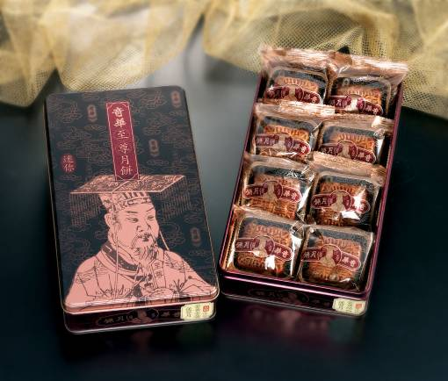 |  | Mini Golden Lotus Seed Paste Mooncakes with Half Yolk  Product Code : KWCN1(To the Mainland)  KWHK1(To Hong Kong)  Retail Price : $198 (To the Mainland)  $168 (To Hong Kong)  Item List:  • 8 pieces per box
Mini White Lotus Seed Paste Mooncakes with Half Yolk
Product Code : KWCN2 (To the Mainland)
KWHK2 (To Hong Kong)
Retail Price : $198 (To the Mainland)
$168 (To Hong Kong)
Item List:
• 8 pieces per box
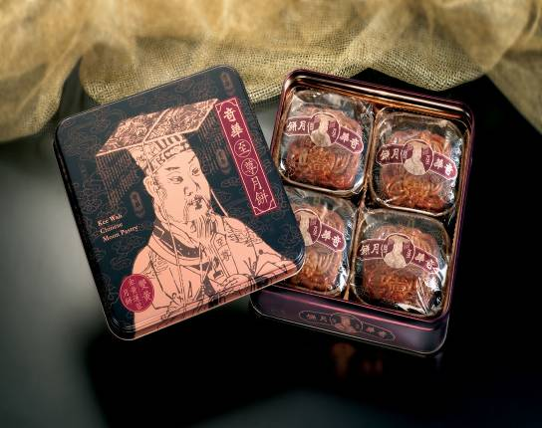 |  | Golden Lotus Seed Paste Mooncakes with Two Yolks  Product Code: KWCN3 (To the Mainland)  KWHK3 (To Hong Kong)  Retail Price : $268 (To the Mainland)  $228 (To Hong Kong)  Item List:  • 4 pieces per box
White Lotus Seed Paste Mooncakes with Two Yolks  Product Code: KWCN4 (To the Mainland)  KWHK4 (To Hong Kong)  Retail Price : $268 (To the Mainland)  $228 (To Hong Kong)  Item List:  • 4 pieces per box |  |  | 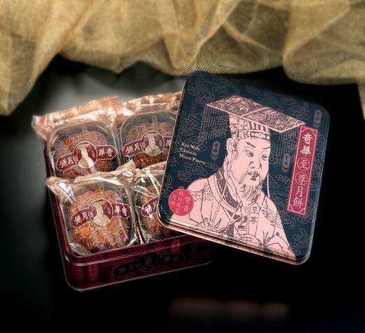
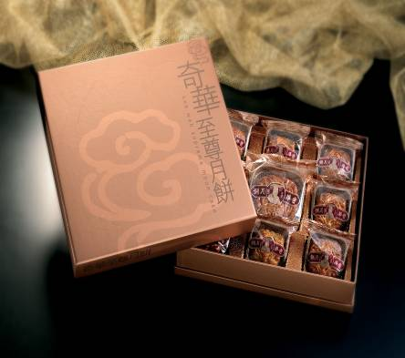 | Assorted Gift Box  Product Code : KWCN5 (To the Mainland)  KWHK5 (To Hong Kong)  Retail Price : $268 (To the Mainland)  $228 (To Hong Kong)  Item List:  - Golden Lotus Seed Paste Mooncake with Two Yolks x 1  - Mini White Lotus Seed Paste Mooncake with Half Yolk x 1  - Mini Golden Lotus Seed Paste Mooncake with Half Yolk x 1  - Mini Chinese Ham Mooncake x 1  - Mini Pineapple Paste Mooncake with Half Yolk x 1  - Mini Black Date Paste Mooncake x 1  - Mini Walnut and Coconut Paste Mooncake x 1  - Mini Green Bean Paste Mooncake with Mixed Yolk x 1  - Mini Red Bean Paste Mooncake with Half Yolk x 1
Royal Gift Box  Product Code : KWCN6 (To the Mainland)  KWHK6 (To Hong Kong)  Retail Price : $738 (To the Mainland)  $668 (To Hong Kong)  Item List:  • Golden Lotus Seed Paste Mooncake with  Four Yolks x 4  - Golden Lotus Seed Paste Mooncake with  Two Yolks x 4  - Mini Golden Lotus Seed Paste Mooncake with  Half Yolk x 9 |  |  | 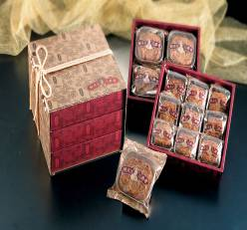
*All delivery charges to local addresses and the major cities in the Mainland are included.

“Wing Wah” Mooncake Gift Sets (Made in Hong Kong)

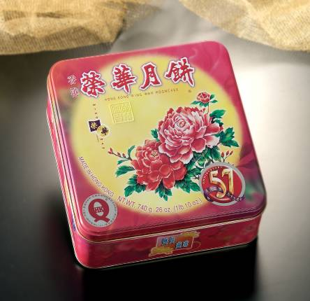 | Lotus Seed Paste Mooncake with Two Yolks  Product Code : WHCN7 (To the Mainland)  WHHK7(To Hong Kong)  Retail Price : $328 (To the Mainland)  $268 (To Hong Kong)  Item List:  - 4 pieces per box
White Lotus Seed Paste Mooncake with Two Yolks  Product Code : WHCN8 (To the Mainland)  WHHK8 (To Hong Kong)  Retail Price : $328 (To the Mainland)  $268 (To Hong Kong)  Item List:  • 4 pieces per box |  |  | 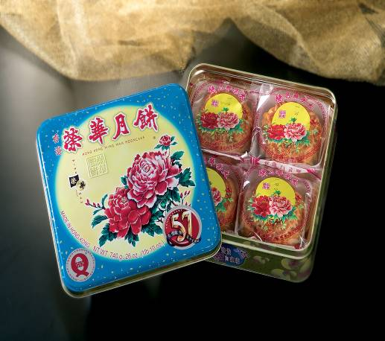
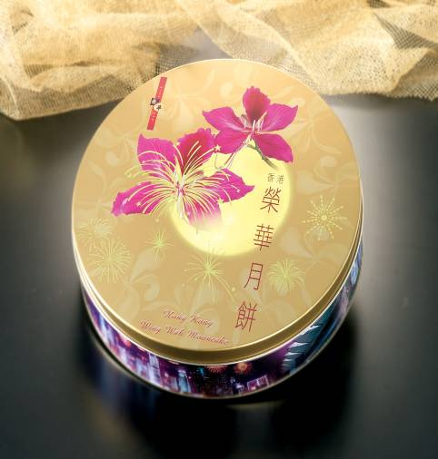 |  | Mini Assorted Mooncakes  Product Code : WHCN9 (To the Mainland)  WHHK9 (To Hong Kong)  Retail Price : $388 (To the Mainland)  $288 (To Hong Kong)  Item List:  - White Lotus Seed Paste Mooncake with Three Yolks x 1  - Mini White Lotus Seed Paste Mooncake with Half Yolk x 7

*All delivery charges to local addresses and the major cities in the Mainland are included.

“Guangdong” Mooncake Gift Sets (Exclusively distributed by China Post, made in China)
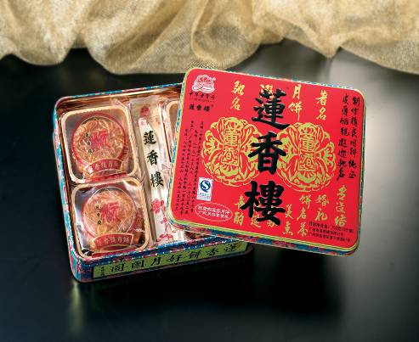 | White Lotus Seed Paste Mooncakes with Two Yolks  Product Code : CNGS01 (To the Mainland)  Retail Price : HK$168  Item List:  - White Lotus Seed Paste Mooncakes with Two Yolks x 4 • Mixed Nuts Mooncake x 1
Mini Assorted Mooncakes  Product Code : CNGS02 (To the Mainland)  Retail Price : HK$198  Item List:  - White Lotus Seed Paste Mooncake with Yolk x 1  - Golden Lotus Seed Paste Mooncakes with Yolk x 2  - Red Bean Paste Mooncakes x 3  - Mooncakes with Mixed Nuts x 2 |  | 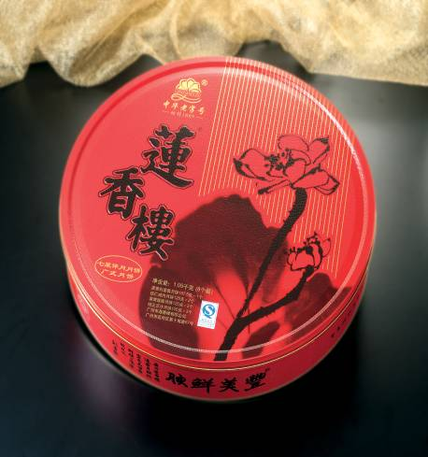
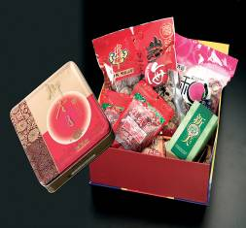 | Supreme Mid Autumn Gift Set  Product Code : CNGS03 (To the Mainland)  Retail Price : HK$328  Item List:  - White Lotus Seed Paste Mooncakes x 4  - Preserved Plums x 1  - Pork Floss x 1  - Preserved Water Melon Seeds x 1  - Pistachios Nuts x 1  - Chinese Tea Leaves (Ti Kuan Yin) x 1  - Greeting Card x 1
Deluxe Mid Autumn Gift Set  Product Code : CNGS04 (To the Mainland)  Retail Price : HK$388  Item List:  - Assorted Fruity Mooncakes x 4  - Dried Longan x 1  - Salted Almonds x 1  - Chinese tea leaves (Pu'er tea) x 1  - Peanuts x 1  - Dried Prunes x 1  - Greeting Card x 1 |  |  | 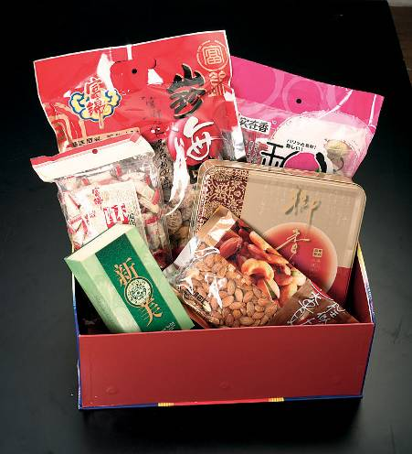

*All delivery charges to the major cities in the Mainland are included.

“Yi Yue” Mooncake Gift Sets (Exclusively distributed by China Post, made in China)
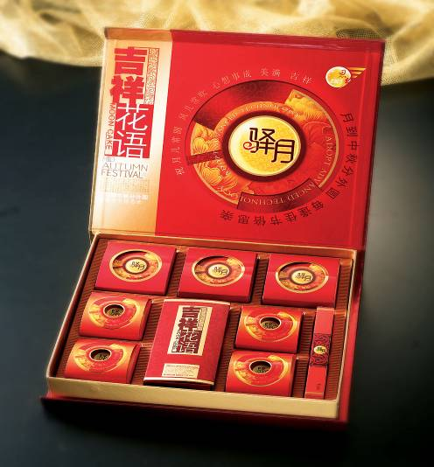 | Mini Assorted Mooncakes  Product Code : BJCN01 (To the Mainland)  Retail Price : HK$288  Item List:  - White Lotus Seed Paste Mooncakes with Two Yolks x 3  - Green Tea White Lotus Seed Paste Mini Mooncakes with Half Yolk x 3  - Black Sesame Paste Mooncakes x 3  • M
Good Luck Assorted Mooncake  Product Code : BJCN02 (To the Mainland)  Retail Price : HK$328  Item List:  - White Lotus Seed Paste Mooncakes with Egg Yolk x 3  - Lily Paste Mini Mooncakes x 4  - Mini Mooncakes with Corn and Eleocharis dulcis x 4 |  | 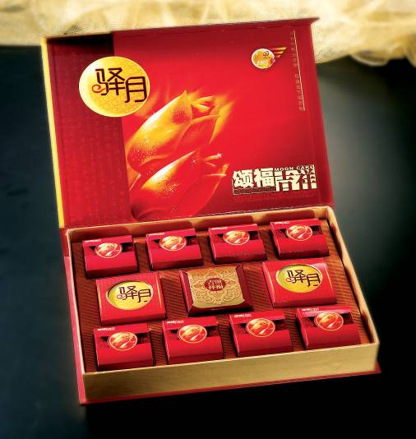
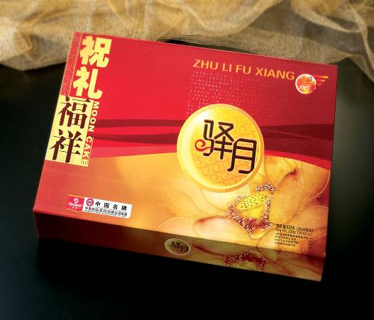 | Best Wishes Assorted Mooncakes  Product Code : BJCN03 (To the Mainland)  Retail Price : HK$368  Item List:  - Golden Lotus Seed Paste Mooncakes with Yolk and Spirulina x 4  - Lily Paste Mooncakes x 2  - Corn and Eleocharis dulcis Paste Mooncakes (80g) x 2  - Deluxe Moooncakes with Shark Fin x 2
Premium Deluxe Assorted Mooncakes  Product Code : BJCN04 (To the Mainland)  Retail Price : HK$388  Item List:  - White Lotus Seed Paste Mooncake with Two Yolks x 1  - Golden Lotus Seed Paste Mooncakes with Yolk and Spirulina x 3  - Lily Paste Mooncakes x 3  - Deluxe Moooncakes with Abalones x 2  - Deluxe Moooncakes with Shark Fin x 2 |  |  | 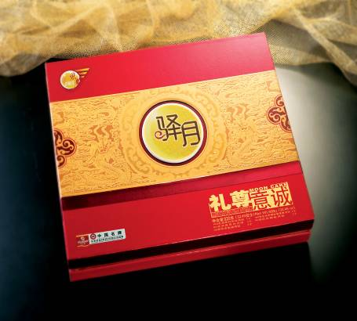

*All delivery charges to local addresses and the major cities in the Mainland are included.

