Appendix 1

LovePost - PostShop Valentine’s Day Gift Sets
Available for mail order at all post offices and ShopThruPost (www.shopthurpost.hk)
from 17.1.2008 to 5.2.2008

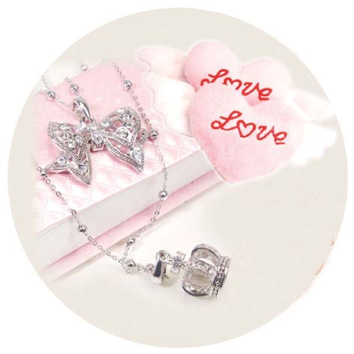

“My Princess” Gift Set
(Price: HK$550)

Product: “My Princess” Gift Set

Price: $550 (including the Local CourierPost delivery charge)

Description:
- ‘Prince Crown with Ribbon’ necklace
- A pair of heart-shaped clasps

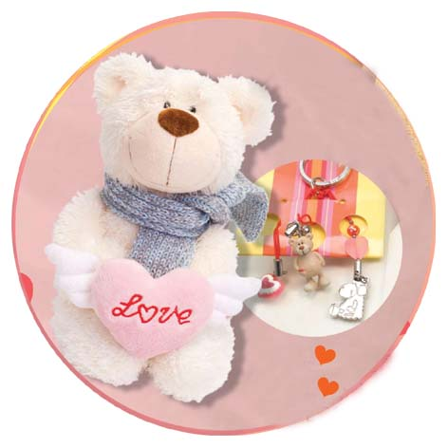

“My Love” Gift Set
(Price: HK$298)

Product: “My Love” Gift Set

Price: $298 (including the Local CourierPost delivery charge)

Description:
- A Winter Bear fluffy holding with a heart-shaped clasp
- A Love Bear keyring

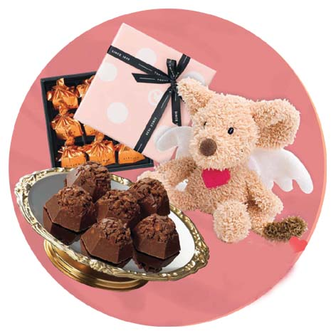

“My Sweetie” Gift Set
(Price: HK$198)

Product: “My Sweetie” Gift Set

Price: $198 (including the Local CourierPost delivery charge)

Description:
- Japanese handmade chocolate box set
- A Mouse Guardian Angel stopper tag

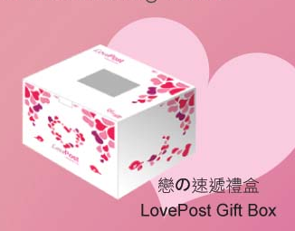
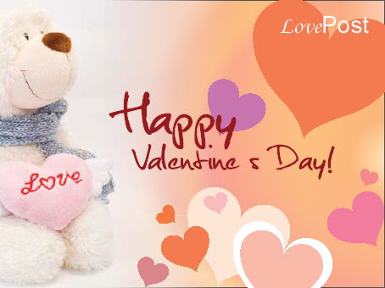
Gift Card LovePost Gift Box

Description: A Gift Card and LovePost Gift Box will be given free-of-charge with each order of a PostShop Valentine’s Day Gift Set.

