Appendix 2
Japanese Cake Gift Sets (available at ShopThruPost from 17 January 2008)
Available for online ordering exclusively at ShopThruPost (www.shopthrupost.hk)
Product name | Details | Price *
SiBelle Brandy Cake  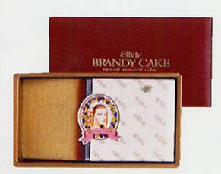 | Using the renowned brandy in France, this gives the cake a rich scent of brandy but still gentle enough for those who doesn’t like alcohol much.  Weight: 400g | $250
SiBelle Chocolate Cake  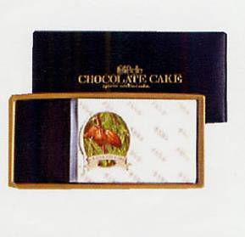 | With a bit of brandy in it, you slightly taste the bitterness of chocolate without having the “too sweet” impression of chocolate cake.  Weight: 350g | $250
SiBelle Baked Cheese Cake  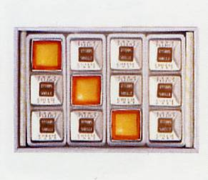 | A premium cheese cake made from a blend of Denmark and Japan cream cheese. Its thick and rich flavor is wrapped inside a baked crusty biscuit, while the lemon flavor adds freshness and balances this rich flavor.
 | Weight: 500g (12 pieces) | $360
 | Weight: 180g (6 pieces) | $230
* prices include Speedpost postage for product sent from Japan

