Appendix I

9th Inter-School Stamp Exhibits Competition

Impressions of the Special Postmark, Cachet and Official Souvenir Cover are reproduced below:



Special Postmark
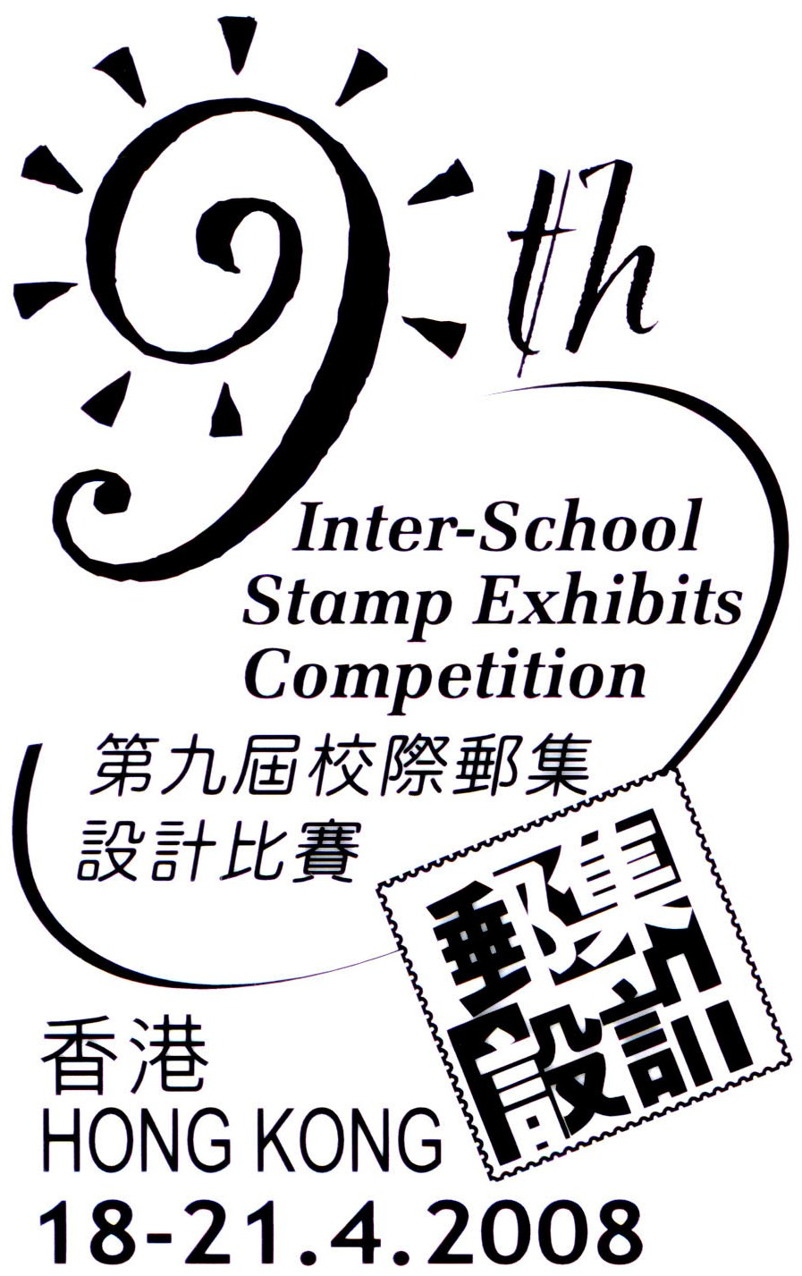
Cachet
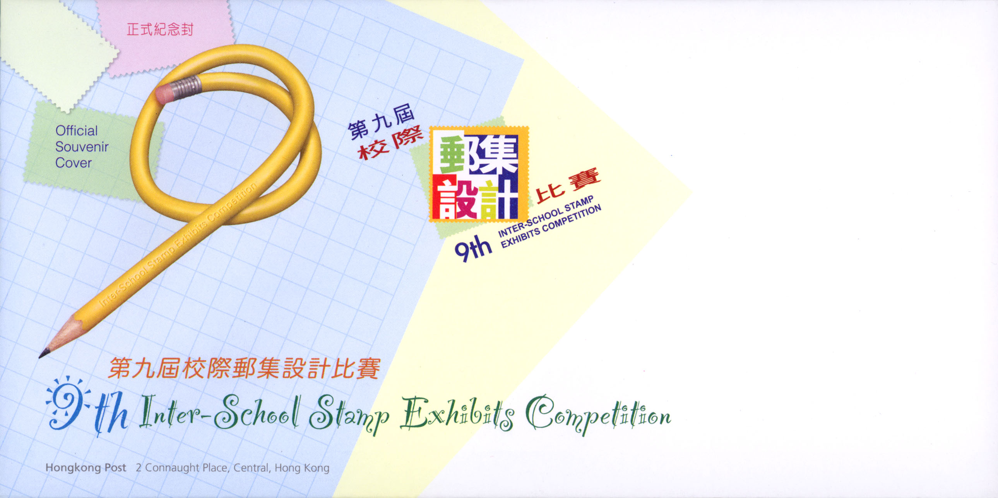
Official Souvenir Cover

