APPENDIX 2

“Giant Pandas” – Limited Edition Prestige Stamp Products
with Giant Panda Paw Print (1 July 2008)

FACT SHEET

Appointed by Ying Ying and Le Le, Hongkong Post is now collecting their paw prints for the production of Limited Edition Prestige Stamp Products with Giant Panda Paw Print, in order to raise funds to support the reconstruction of the Giant Pandas’ habitats in the Mainland. All money raised will support the rebuilding of panda facilities in Sichuan through the “Sichuan Earthquake Relief Giant Panda Base Rebuilding Fund” set up by Ocean Park Conservation Foundation Hong Kong.

The Limited Edition Prestige Stamp Products with Giant Panda Paw Print are available in two designs:

Product | Unit  Selling Price | Total Quantity Issued
“Giant Pandas” – Limited Edition Prestige Stamp Box Set with Clay Impression of Giant Panda Paw Print  It contains:  - A set of 4 “Giant Pandas” special stamps  - A “Giant Pandas” special stamp Mini-pane  - A Serviced First Day Cover affixed with a set of 4 “Giant Pandas” special stamps and datestamped with the special postmark on 1.7.2008.  - A clay impression of Ying Ying or Le Le’s paw print  - A certificate  - Thank you letter from Ying Ying and Le Le | $50,000 | Maximum 10 sets
“Giant Pandas” – Limited Edition Prestige Stamp  Pack with Giant Panda Paw Print  It contains:  - A set of 4 “Giant Pandas” special stamps  - A “Giant Pandas” special stamp Mini-pane with  images of Ying Ying or Le Le’s paw prints  - Thank you letter from Ying Ying and Le Le | $250 | 2000 packs

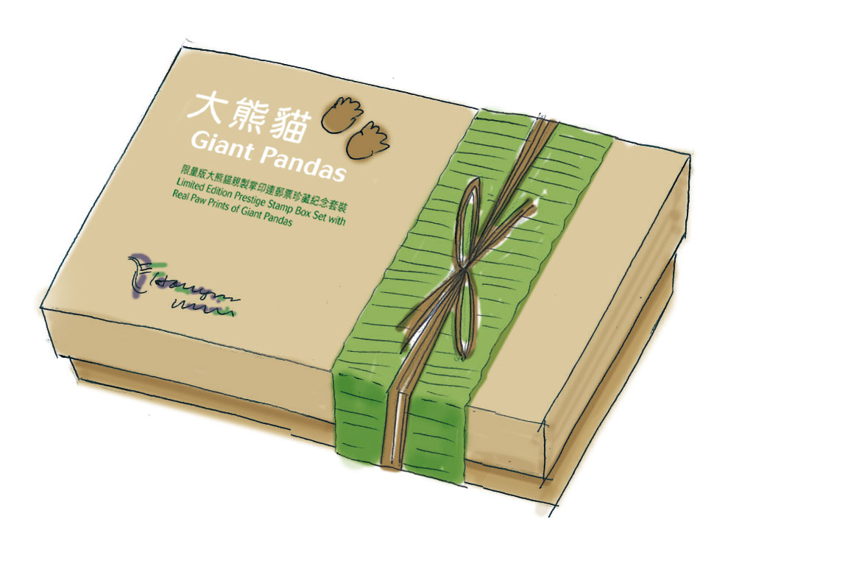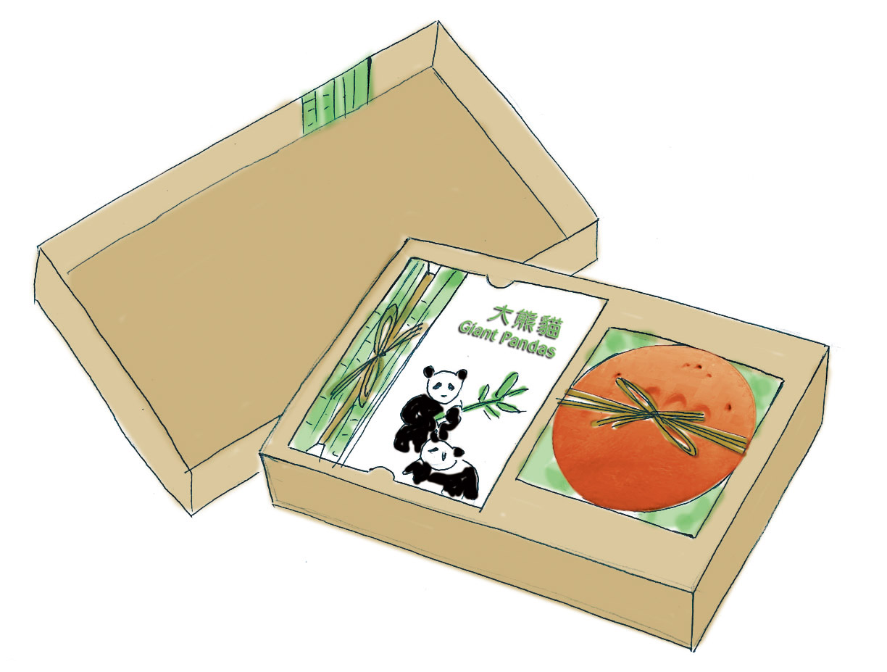
“Giant Pandas” – Limited Edition Prestige Stamp Box Set
with Clay Impression of Giant Panda Paw Print (design subject to change)

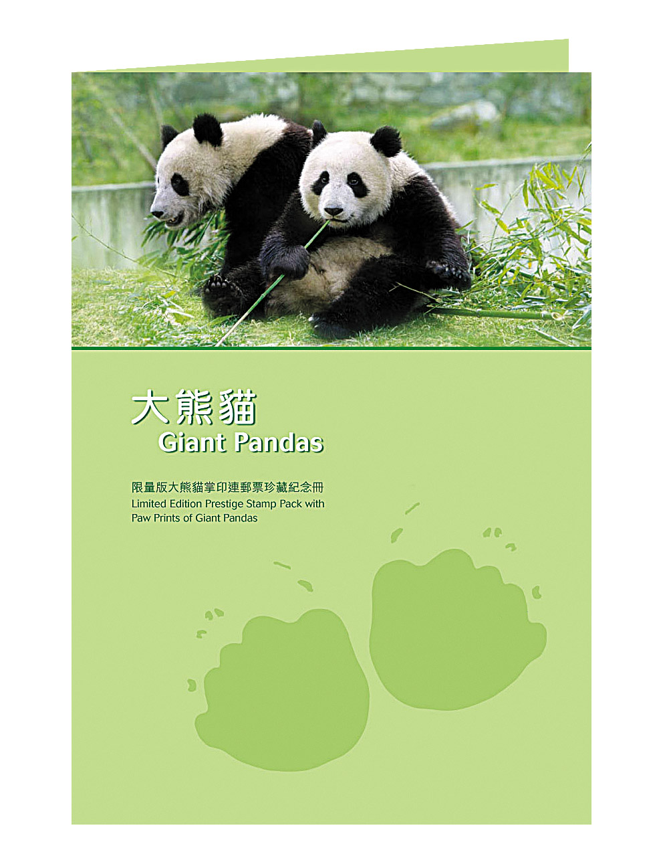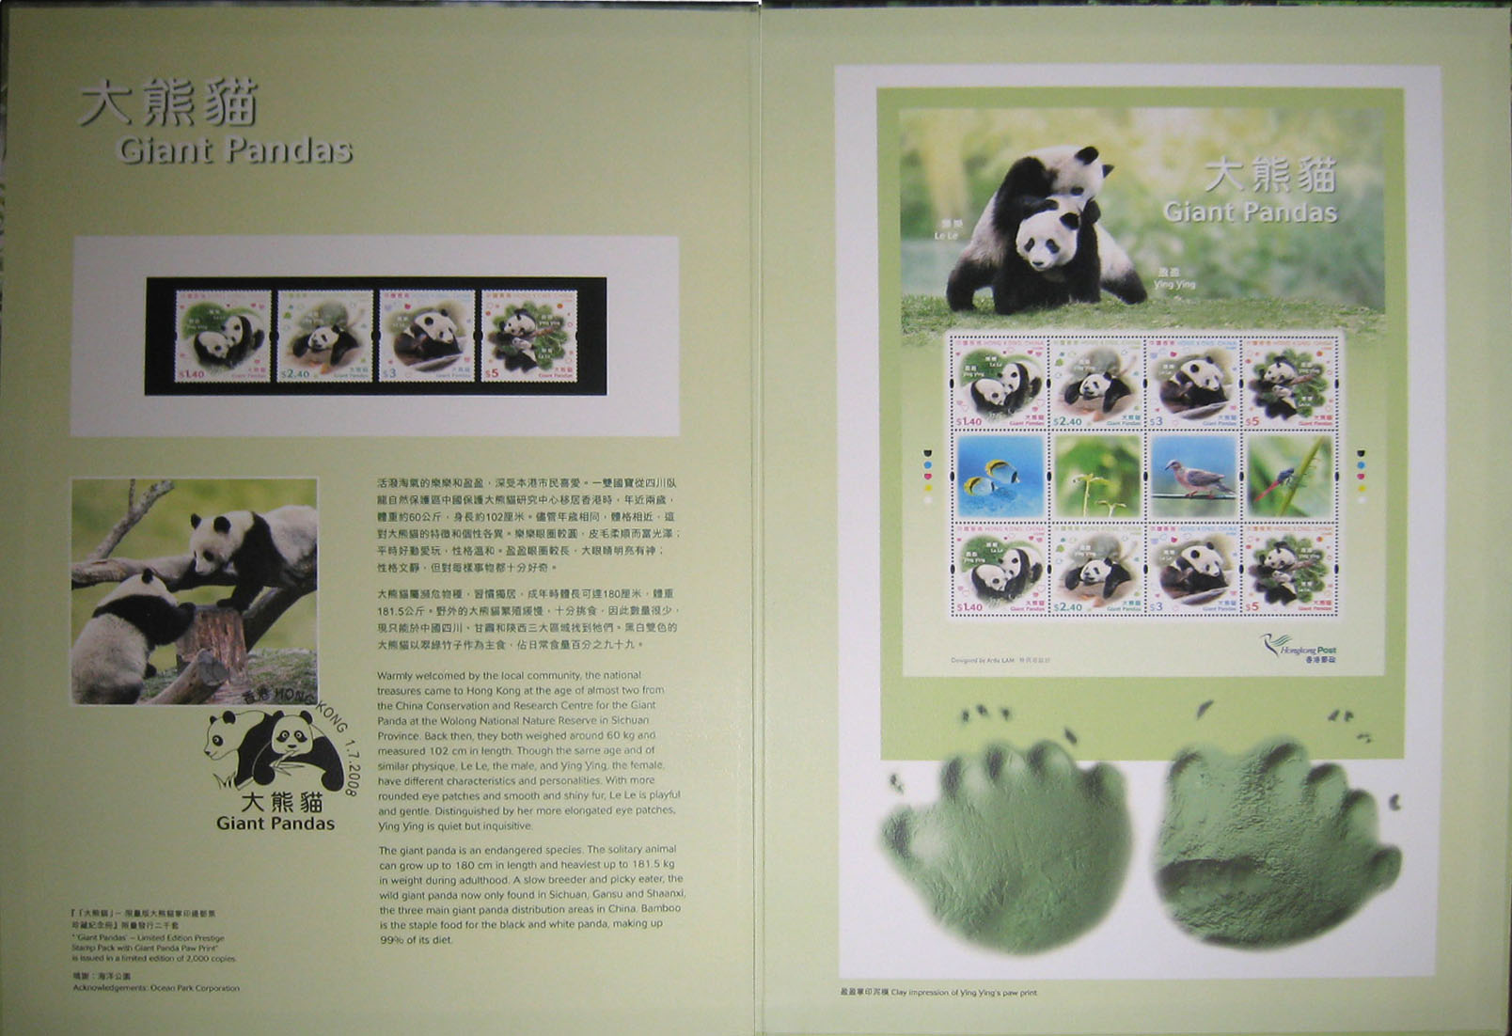
“Giant Pandas” – Limited Edition Prestige Stamp Pack with Giant Panda Paw Print
(design subject to change)

Sales Arrangements
These limited edition products will only be available for subscription through the internet or order forms. Interested customers should make their subscriptions via the Hongkong Post’s website at www.hongkongpost.com, or forward a duly completed subscription form to Hongkong Post. Subscription forms are available at any post offices or from the Hongkong Post website. The deadline for subscription is 19 June 2008. In case of oversubscription, the allocation will be determined through balloting.

Further information about the sale of these limited edition products can be obtained from Hongkong Post’s website at www.hongkongpost.com, or by calling the Hongkong Post Philatelic Bureau hotline 2785 5711.

