Food samples in which Melamine was not detected
沒有檢出含「三聚氰胺」的食物樣本
抽驗結果公布日期：18.9.2008

Serial No.  編號 | Sample  樣本名稱 | Manufacturer’s name & address  製造商名稱及地址 | Photo  相片
12 | Yili Natural choice milk cream – milk  伊利牧場特品牛奶味 (雪糕)  (淨體積: 450毫升)  (Expiry date: 23.3.2010) | Manufacturer: Shanghai Yili AB Foods Co., Ltd  Address: No. 269 Beidou Road, Minhang Zone, Shanghai P.R. of China | 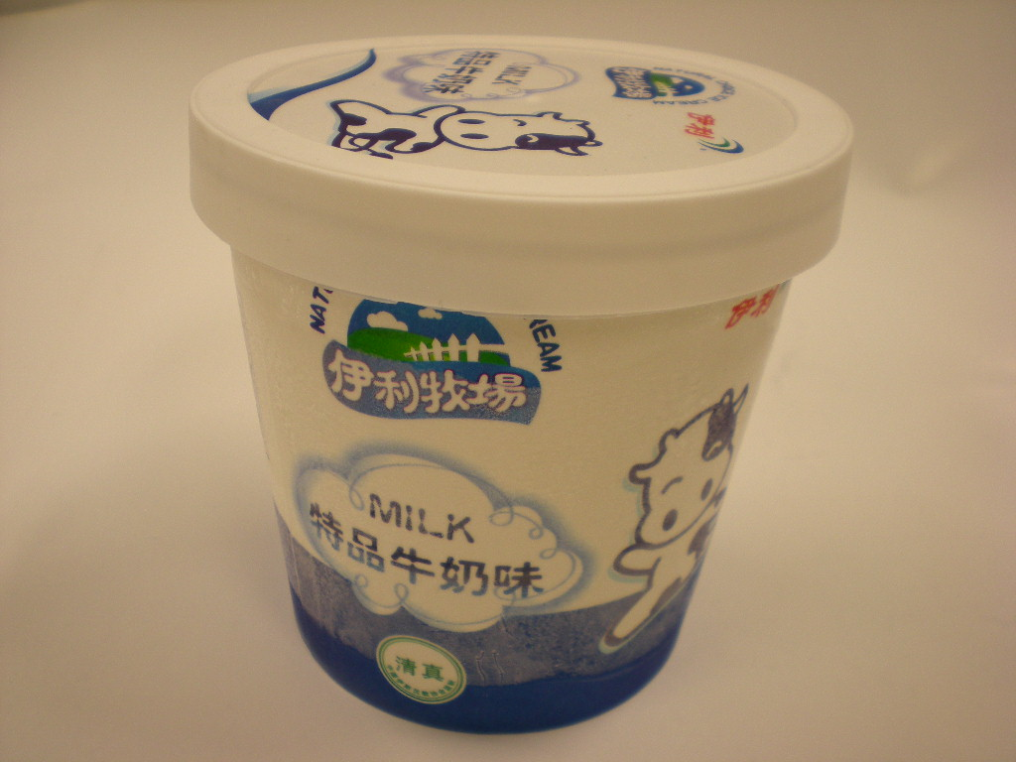
13 | Yili Natural Choice Ice cream – Yogurt  伊利牧場特品酸奶味(雪糕)  (淨體積: 450毫升)  (Expiry date: 14.3.2010) | Manufacturer: Shanghai Yili AB Foods Co., Ltd  Address: No. 269 Beidou Road, Minhang Zone, Shanghai P.R. of China | 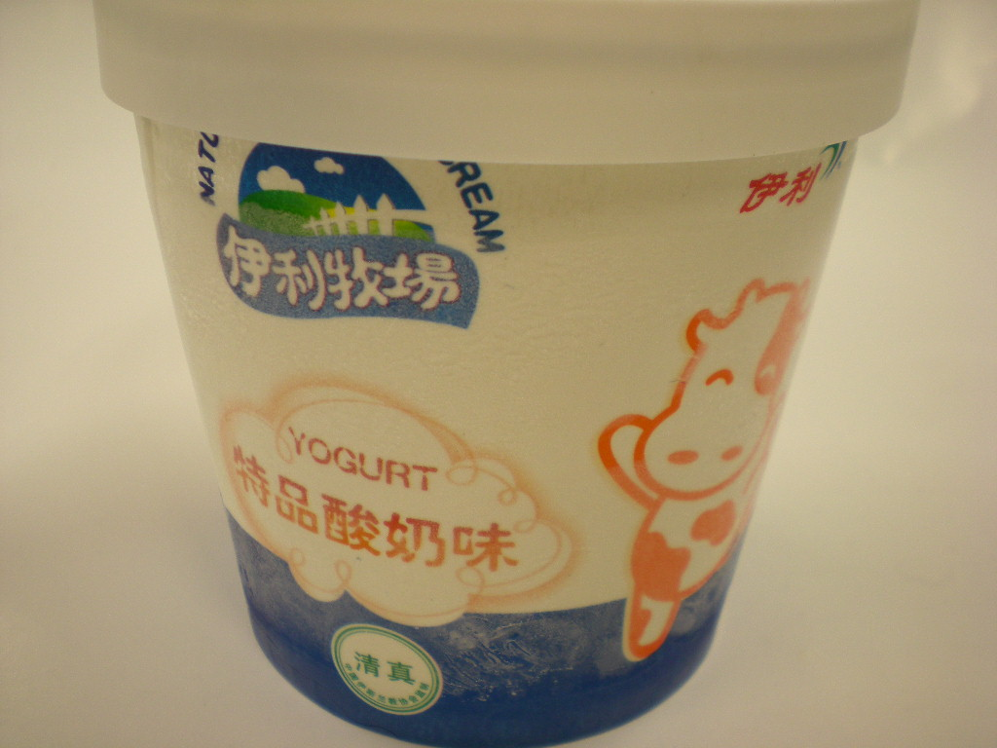
14 | Yili Super Bean Red Bean Chestnut Ice Bar  伊豆 紅豆/板栗(雪條)  (淨體積: 48毫升)  (Expiry date: 8.7.2010) | Manufacturer: Shanghai Yili AB Foods Co., Ltd  Address: No. 269 Beidou Road, Minhang Zone, Shanghai P.R. of China | 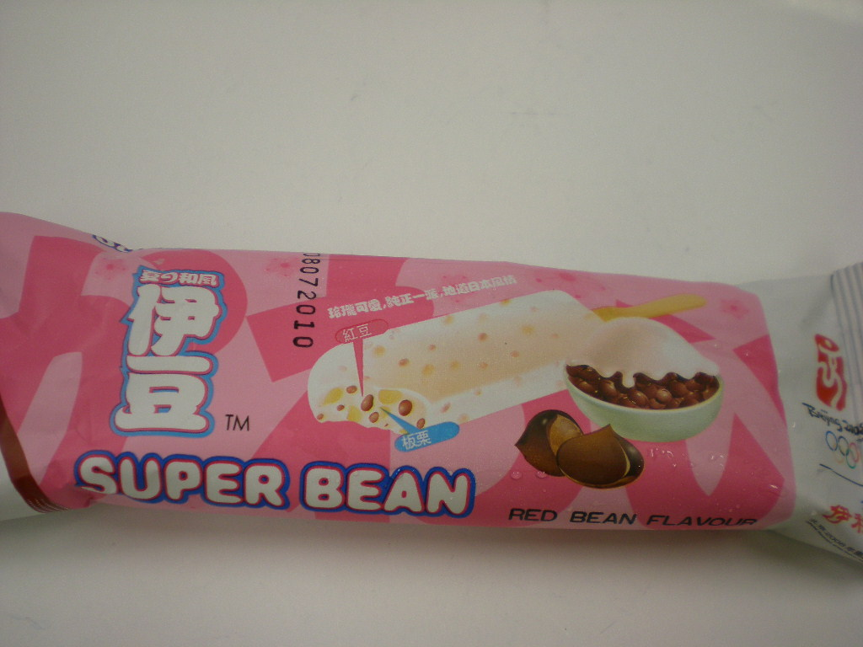
15 | Yili Pure Milk  伊利純牛奶  (淨體積: 1公升)  (Expiry date: 28.2.2009) | Manufacturer: Inner Mongolia Yili Industrial Group Co., Ltd.  內蒙古伊利實業集團股份有限公司  Address: No.2, Jin 3 Ave, Jinchuan Development Zone, Hohhot, Inner Mongolia, China  中國內蒙古呼和浩特市金川開發區金三道2號 | 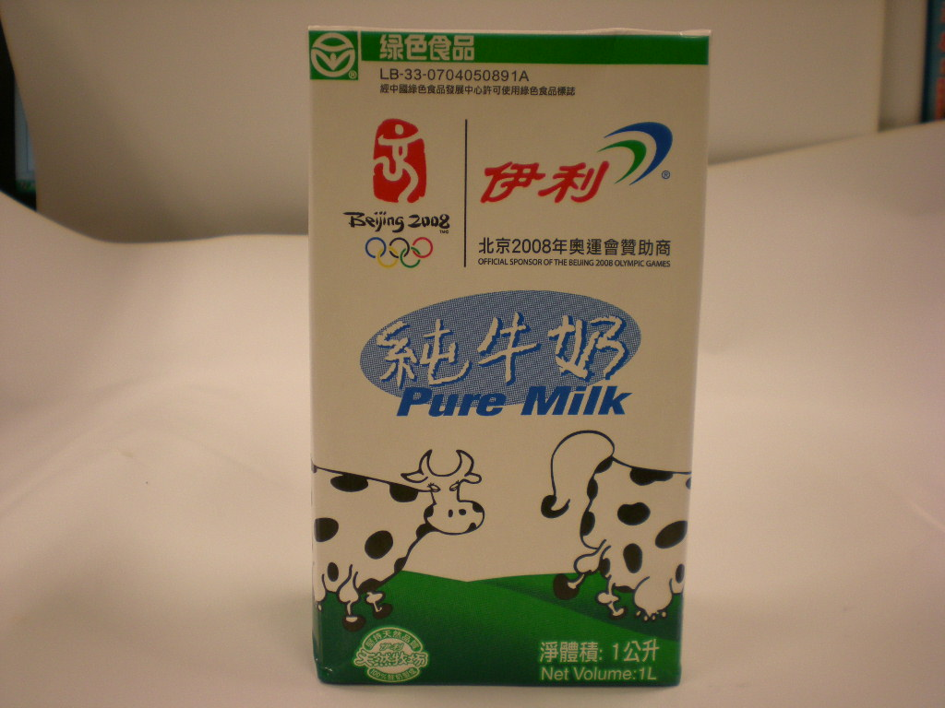
16 | Yili Pure Milk  伊利純牛奶(奧運)  (淨體積: 250毫升)  (Expiry date: 3.3.2009) | Manufacturer: Inner Mongolia Yili Industrial Group Co., Ltd.  內蒙古伊利實業集團股份有限公司  Address: No.2, Jin 3 Ave, Jinchuan Development Zone, Hohhot, Inner Mongolia, China  中國內蒙古呼和浩特市金川開發區金三道2號 | 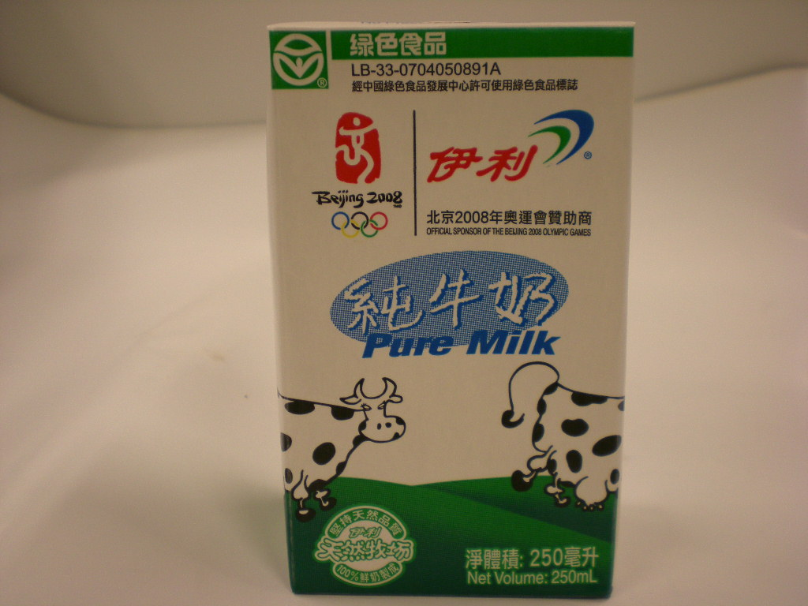
17 | Yili High calcium low fat milk beverage  伊利高鈣低脂奶類飲品(奧運)  (淨體積: 250毫升)  (Expiry date: 3.3.2009) | Manufacturer: Inner Mongolia Yili Industrial Group Co., Ltd.  內蒙古伊利實業集團股份有限公司  Address: No.2, Jin 3 Ave, Jinchuan Development Zone, Hohhot, Inner Mongolia, China  中國內蒙古呼和浩特市金川開發區金三道2號 | 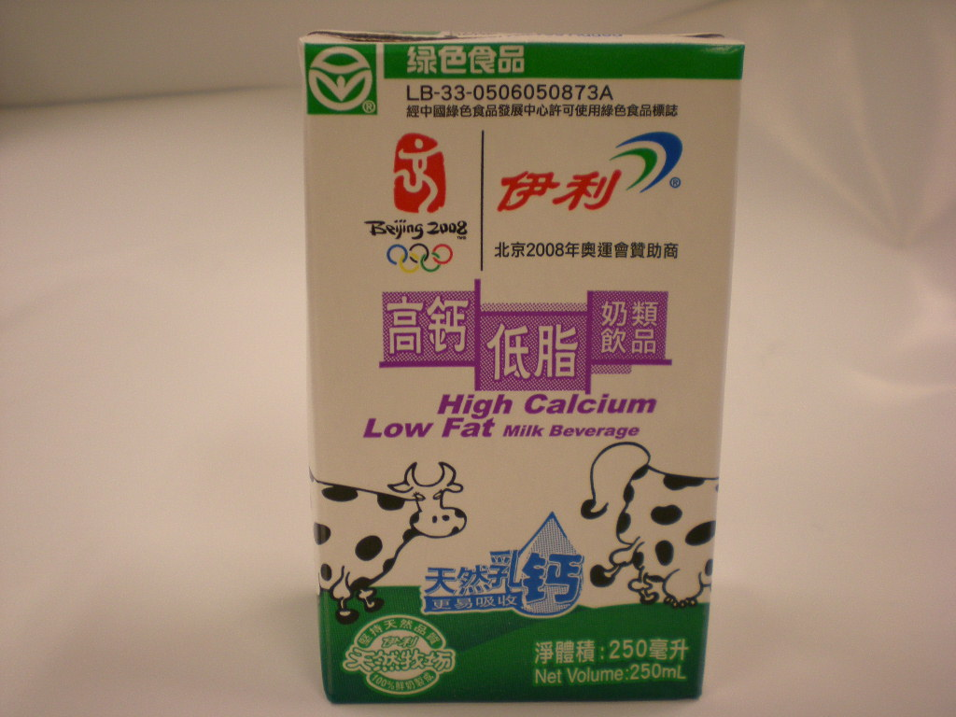
18 | Yili High calcium low fat milk beverage  伊利高鈣低脂奶類飲品  (淨體積: 250毫升)  (Expiry date: 14.2.2009) | Manufacturer: Inner Mongolia Yili Industrial Group Co., Ltd.  內蒙古伊利實業集團股份有限公司  Address: No.2, Jin 3 Ave, Jinchuan Development Zone, Hohhot, Inner Mongolia, China  中國內蒙古呼和浩特市金川開發區金三道2號 | 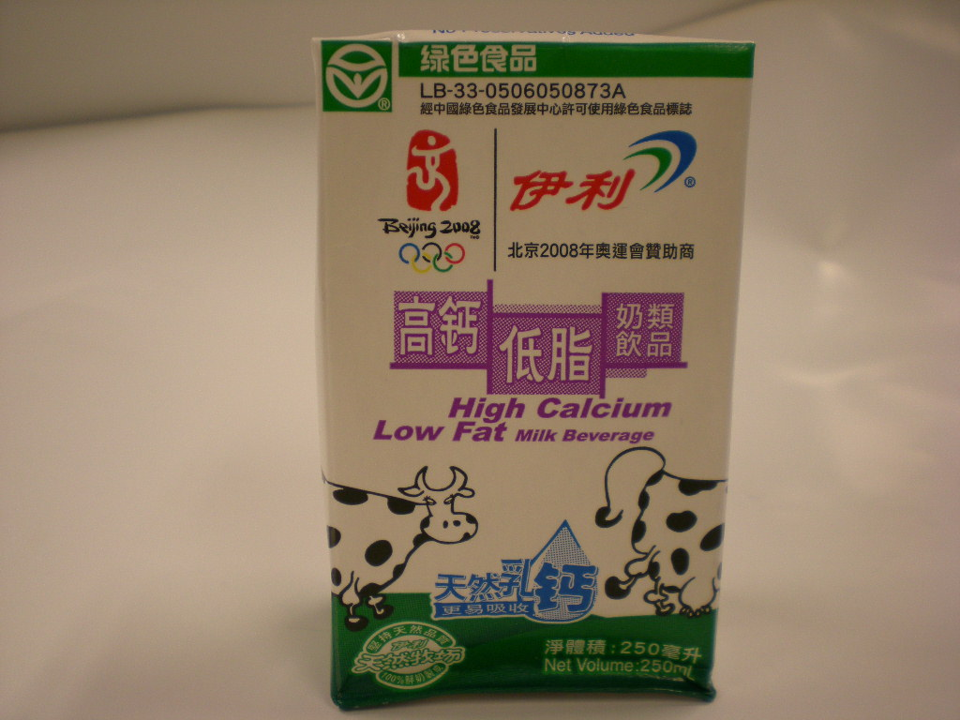
19 | Yili High calcium milk beverage  伊利高鈣奶類飲品  (淨體積: 250毫升)  (Expiry date: 17.1.2009) | Manufacturer: Inner Mongolia Yili Industrial Group Co., Ltd.  內蒙古伊利實業集團股份有限公司  Address: No.2, Jin 3 Ave, Jinchuan Development Zone, Hohhot, Inner Mongolia, China  中國內蒙古呼和浩特市金川開發區金三道2號 | 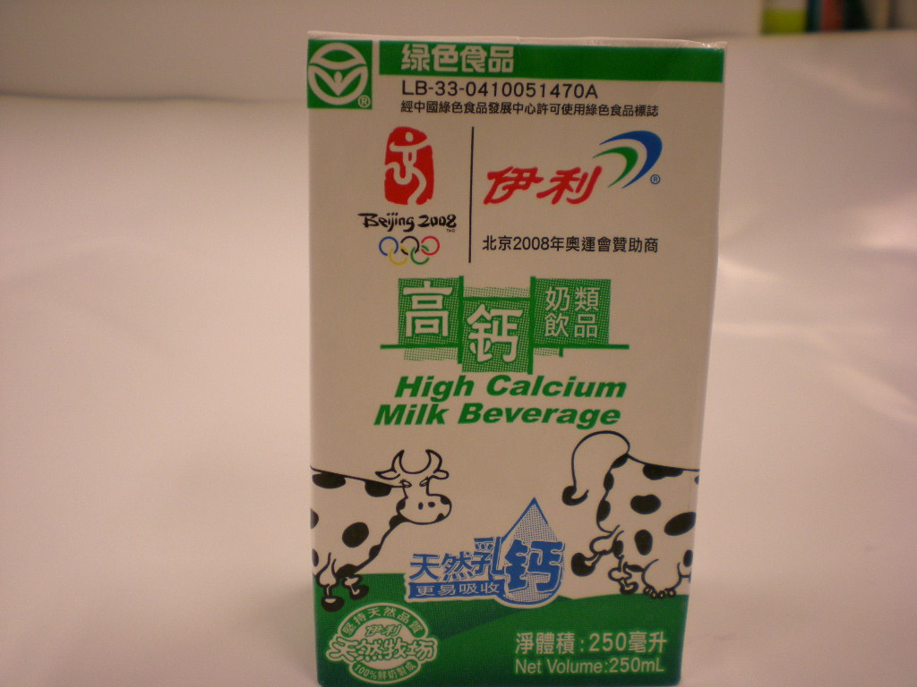
20 | Yili High calcium milk beverage  伊利高鈣奶類飲品  (淨體積: 1公升)  (Expiry date: 17.1.2009) | Manufacturer: Inner Mongolia Yili Industrial Group Co., Ltd.  內蒙古伊利實業集團股份有限公司  Address: No.2, Jin 3 Ave, Jinchuan Development Zone, Hohhot, Inner Mongolia, China  中國內蒙古呼和浩特市金川開發區金三道2號 | 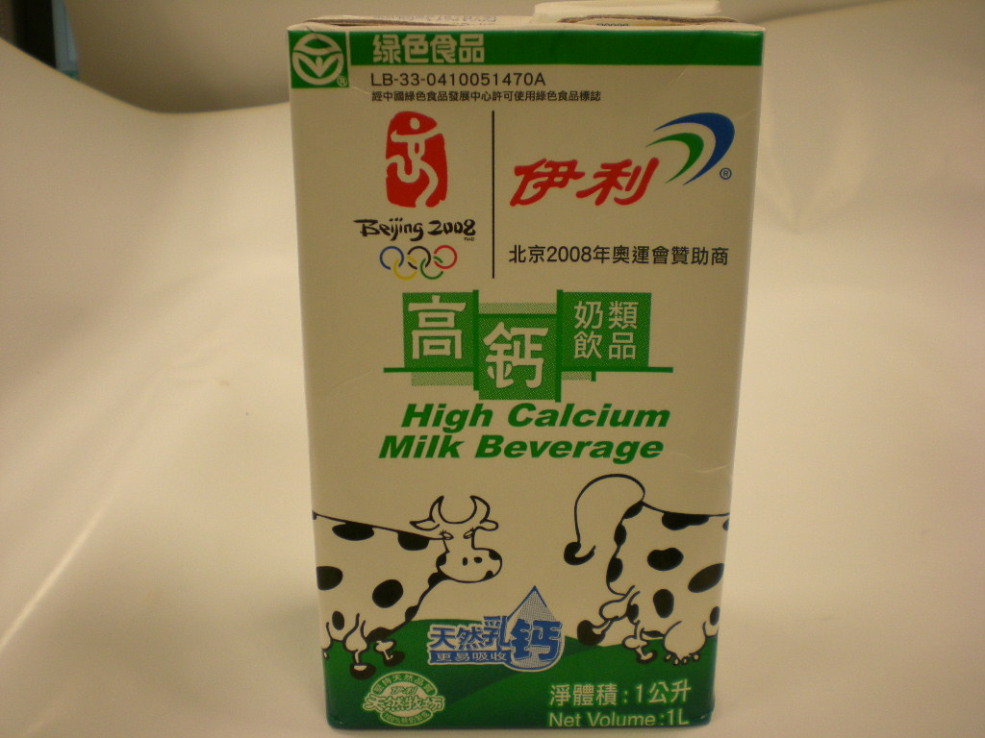
21 | Yili Milk Beverage (Original Taste)  伊利優酸乳奶類飲品(原味)  (淨體積: 6盒裝:6 x 250毫升)  (Expiry date: 28.2.2009) | Manufacturer: Inner Mongolia Yili Industrial Group Co., Ltd.  內蒙古伊利實業集團股份有限公司  Address: No.2, Jin 3 Ave, Jinchuan Development Zone, Hohhot, Inner Mongolia, China  中國內蒙古呼和浩特市金川開發區金三道2號 | 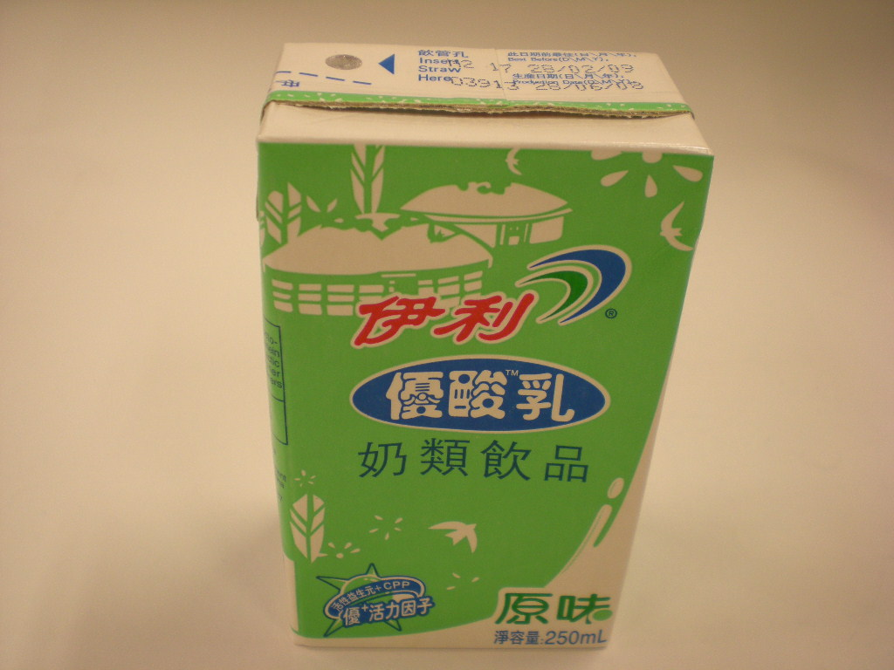
22 | Yili Milk Beverage (Strawberry Taste)  伊利優酸乳奶類飲品(草莓味)  (淨體積: 6盒裝:6 x 250毫升)  (Expiry date: 28.2.2009) | Manufacturer: Inner Mongolia Yili Industrial Group Co., Ltd.  內蒙古伊利實業集團股份有限公司  Address: No.2, Jin 3 Ave, Jinchuan Development Zone, Hohhot, Inner Mongolia, China  中國內蒙古呼和浩特市金川開發區金三道2號 | 