Food samples in which Melamine was detected
被檢出含「三聚氰胺」的食物樣本
抽驗結果公布日期：18.9.2008
Serial No.  編號 | Sample  樣本名稱 | Manufacturer’s name & address  製造商名稱及地址 | Melamine detected  「三聚氰胺」含量 | Photo  相片
1 | Yili Super Bean Red Bean Chestnut Ice Bar  伊利伊豆 紅豆/板栗 (雪條)  (淨體積: 48毫升)  (Expiry date: 8.6.2010) | Manufacturer: Shanghai Yili AB Foods Co., Ltd  Address: No. 269 Beidou Road, Minhang Zone, Shanghai P.R. of China | 21 ppm | 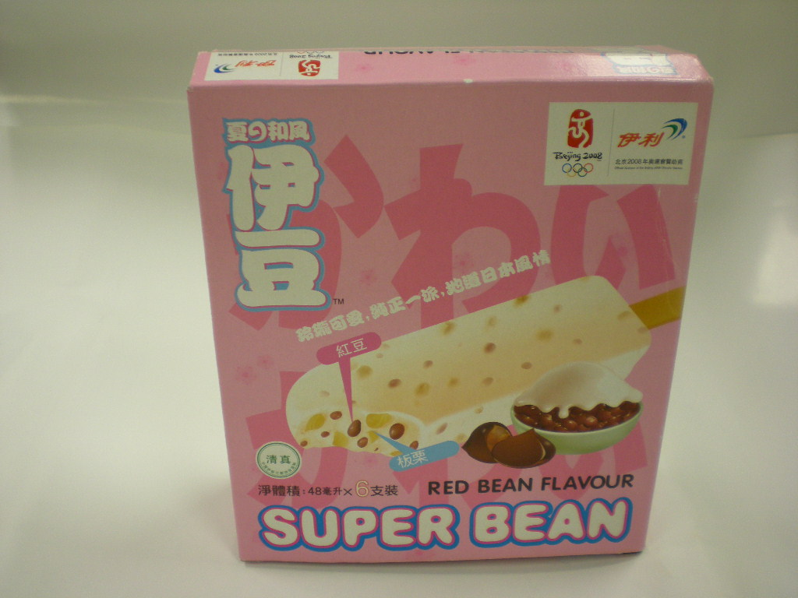
2 | Yili Bean Club- Matcha red bean ice bar  伊利佰豆集 抹茶紅豆(雪條)  (淨體積: 87毫升)  (Expiry date: 6.5.2010) | Manufacturer: Shanghai Yili AB Foods Co., Ltd  Address: No. 269 Beidou Road, Minhang Zone, Shanghai P.R. of China | 4.4 ppm | 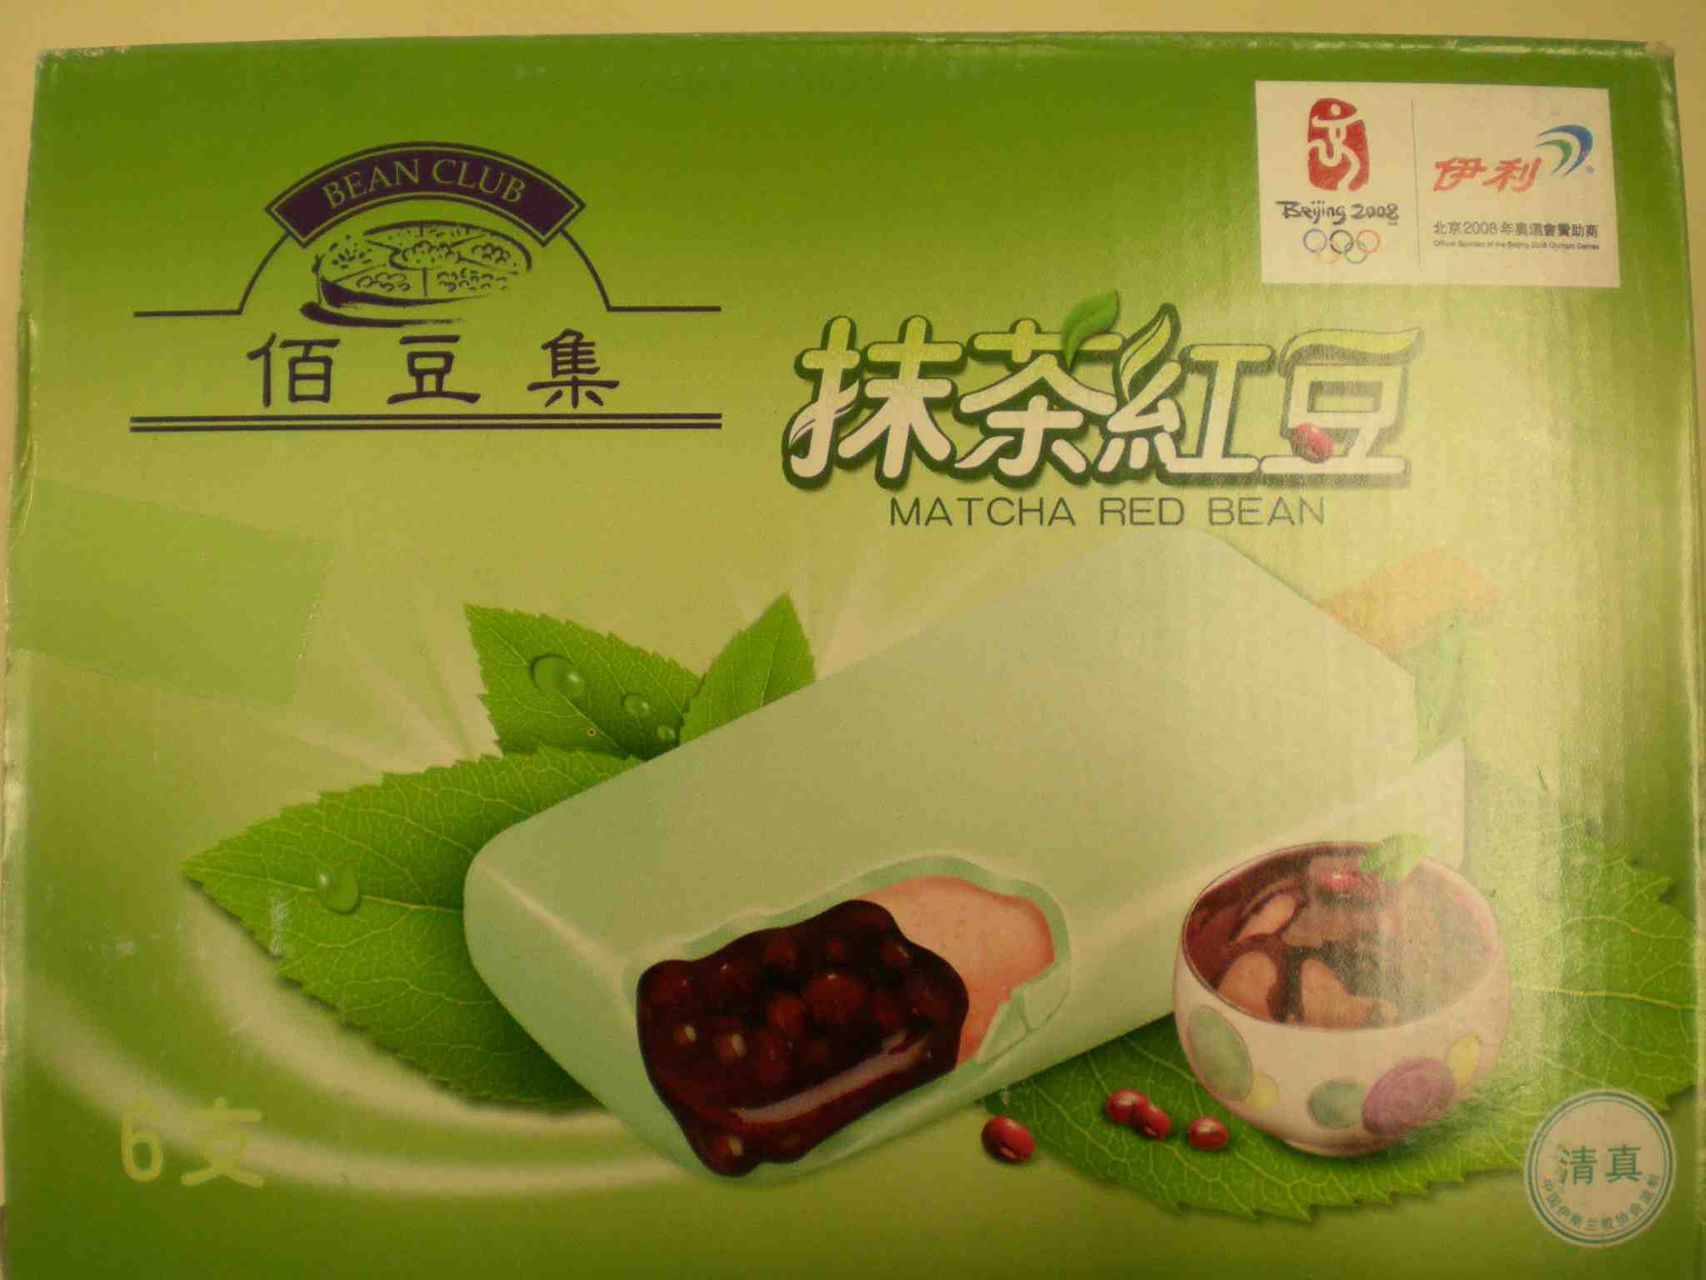
3 | Yili High Calcium Milk Beverage  伊利高鈣奶類飲品  (淨體積: 1公升)  (Expiry date: 15.11.2008) | Manufacturer: Inner Mongolia Yili Industrial Group Co., Ltd.  內蒙古伊利實業集團股份有限公司  Address: No.2, Jin 3 Ave, Jinchuan Development Zone, Hohhot, Inner Mongolia, China  中國內蒙古呼和浩特市金川開發區金三道2號 | 5.5 ppm | 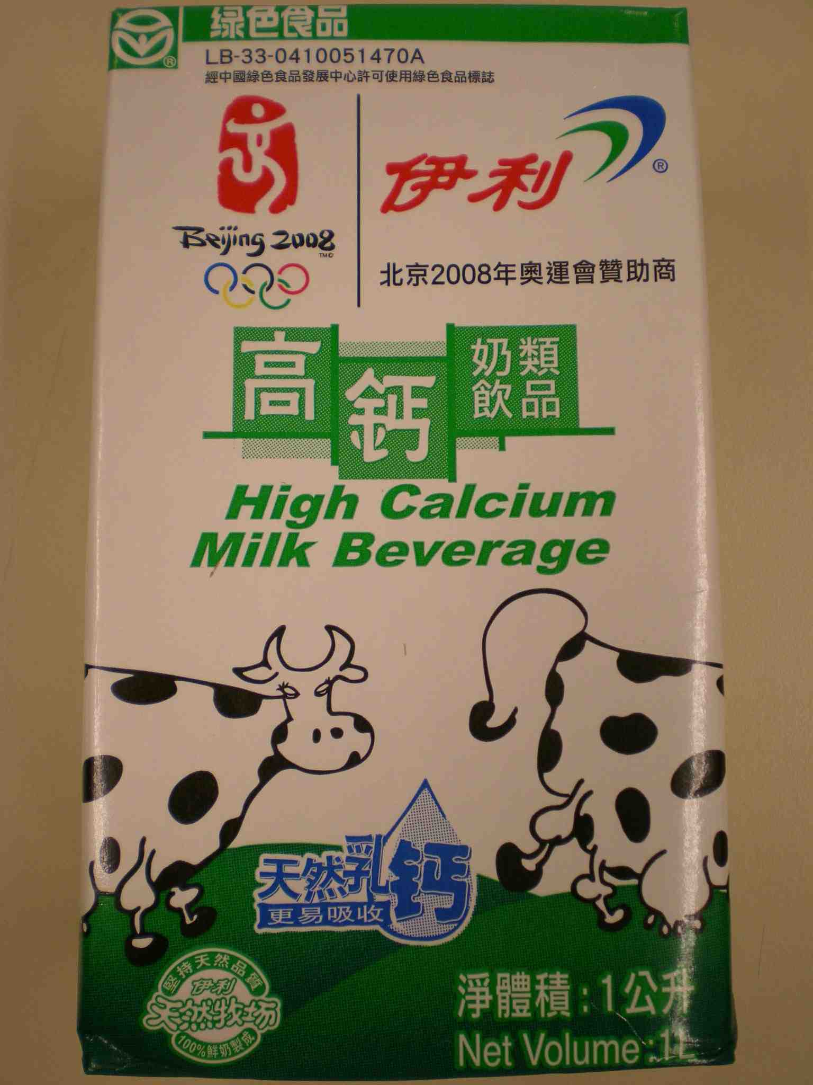
4 | Yili Bean Club- Red bean milk bar  伊利佰豆集 牛奶蜜豆(雪條)  (淨體積: 95毫升)  (Expiry date: 2.6.2010) | Manufacturer: Shanghai Yili AB Foods Co., Ltd  Address: No. 269 Beidou Road, Minhang Zone, Shanghai P.R. of China | 5 ppm | 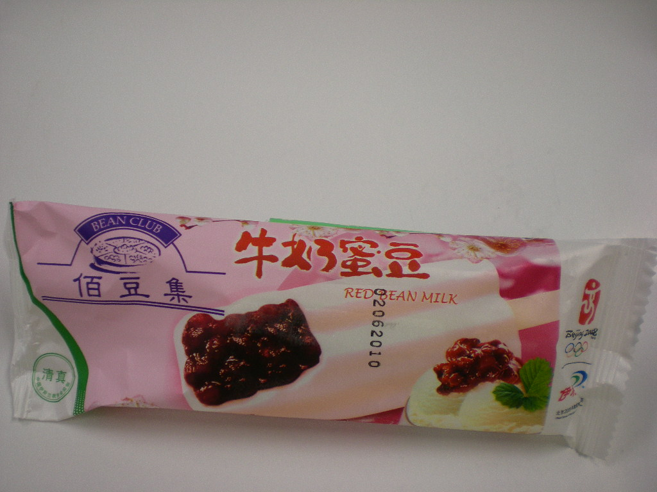
5 | Yili Prestige Chocliz - Dark Chocolate Bar  伊利臻品巧樂茲-黑朱古力味(雪條)  (淨體積: 100毫升)  (Expiry date: 24.3.2010) | Manufacturer: Shanghai Yili AB Foods Co., Ltd  Address: No. 269 Beidou Road, Minhang Zone, Shanghai P.R. of China | 13 ppm | 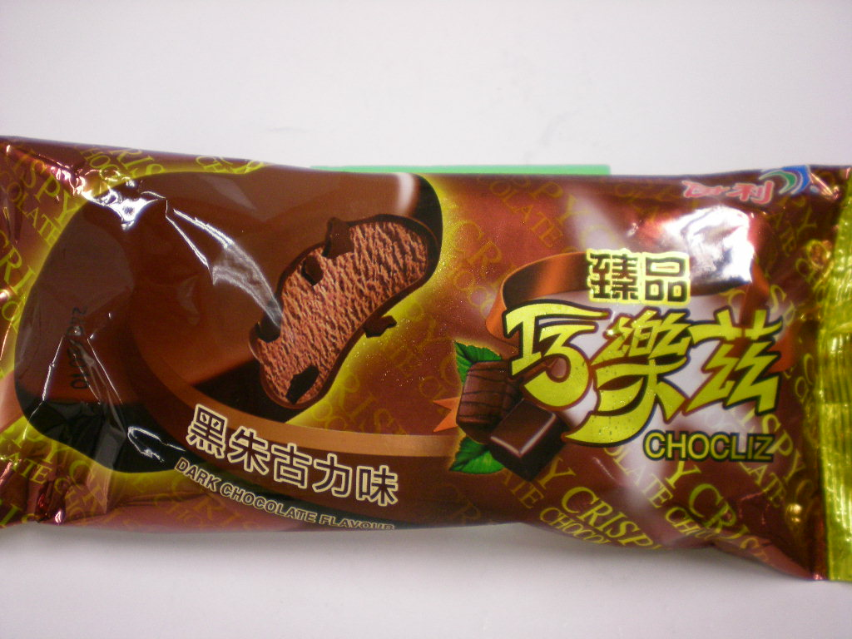
6 | Yili Pure Milk  伊利純牛奶  (淨體積: 250毫升)  (Expiry date: 28.2.2009) | Manufacturer: Inner Mongolia Yili Industrial Group Co., Ltd.  內蒙古伊利實業集團股份有限公司  Address: No.2, Jin 3 Ave, Jinchuan Development Zone, Hohhot, Inner Mongolia, China  中國內蒙古呼和浩特市金川開發區金三道2號 | 2.2 ppm | 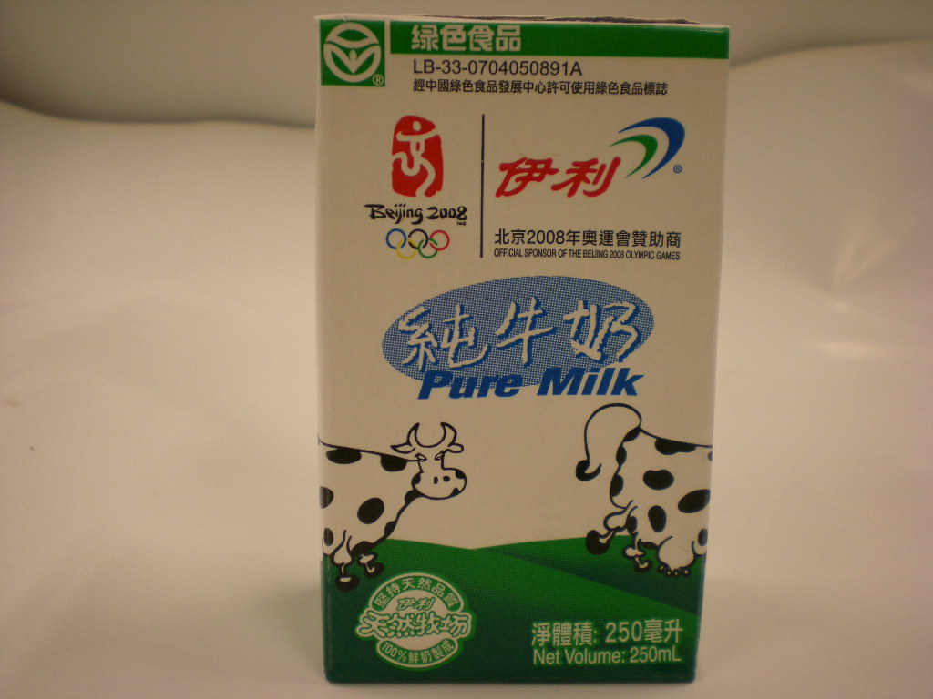
7 | Yili Pure Milk  伊利純牛奶  (淨體積: 1公升)  (Expiry date: 26.3.2009) | Manufacturer: Inner Mongolia Yili Industrial Group Co., Ltd.  內蒙古伊利實業集團股份有限公司  Address: No.2, Jin 3 Ave, Jinchuan Development Zone, Hohhot, Inner Mongolia, China  中國內蒙古呼和浩特市金川開發區金三道2號 | 3.5 ppm | 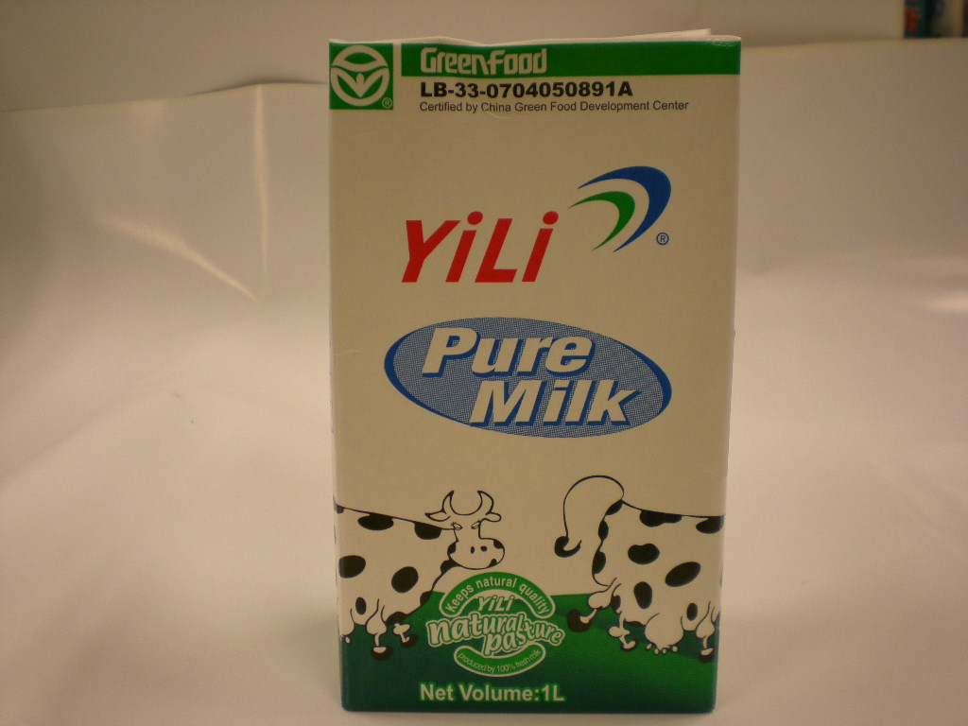
8 | Yili High calcium low fat milk beverage  伊利高鈣低脂奶類飲品  (淨體積: 1公升)  (Expiry date: 2.4.2009) | Manufacturer: Inner Mongolia Yili Industrial Group Co., Ltd.  內蒙古伊利實業集團股份有限公司  Address: No.2, Jin 3 Ave, Jinchuan Development Zone, Hohhot, Inner Mongolia, China  中國內蒙古呼和浩特市金川開發區金三道2號 | 9.9 ppm | 