Food samples in which Melamine was not detected
沒有檢出含「三聚氰胺」的食物樣本
抽驗結果公布日期：18.9.2008
Serial No.  編號 | Sample  樣本名稱 | Manufacturer’s name & address  製造商名稱及地址 | Photo  相片
1 | Yili Milk Beverage (Original Taste)  伊利優酸乳奶類飲品 (原味)  (淨體積: 6盒裝:6 x 250毫升)  (Expiry date: 28.2.2009) | Manufacturer: Inner Mongolia Yili Industrial Group Co., Ltd.  內蒙古伊利實業集團股份有限公司  Address: No.2, Jin 3 Ave, Jinchuan Development Zone, Hohhot, Inner Mongolia, China  中國內蒙古呼和浩特市金川開發區金三道2號 | 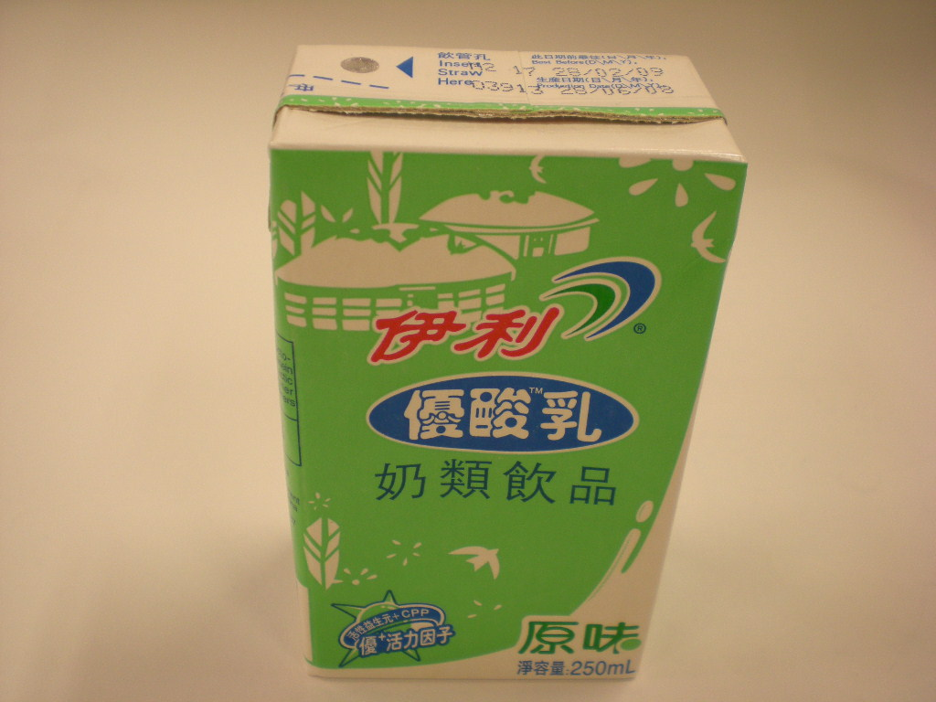
2 | Yili Milk Beverage (Strawberry Taste)  伊利優酸乳奶類飲品 (草莓味)  (淨體積: 6盒裝:6 x 250毫升)  (Expiry date: 28.2.2009) | Manufacturer: Inner Mongolia Yili Industrial Group Co., Ltd.  內蒙古伊利實業集團股份有限公司  Address: No.2, Jin 3 Ave, Jinchuan Development Zone, Hohhot, Inner Mongolia, China  中國內蒙古呼和浩特市金川開發區金三道2號 | 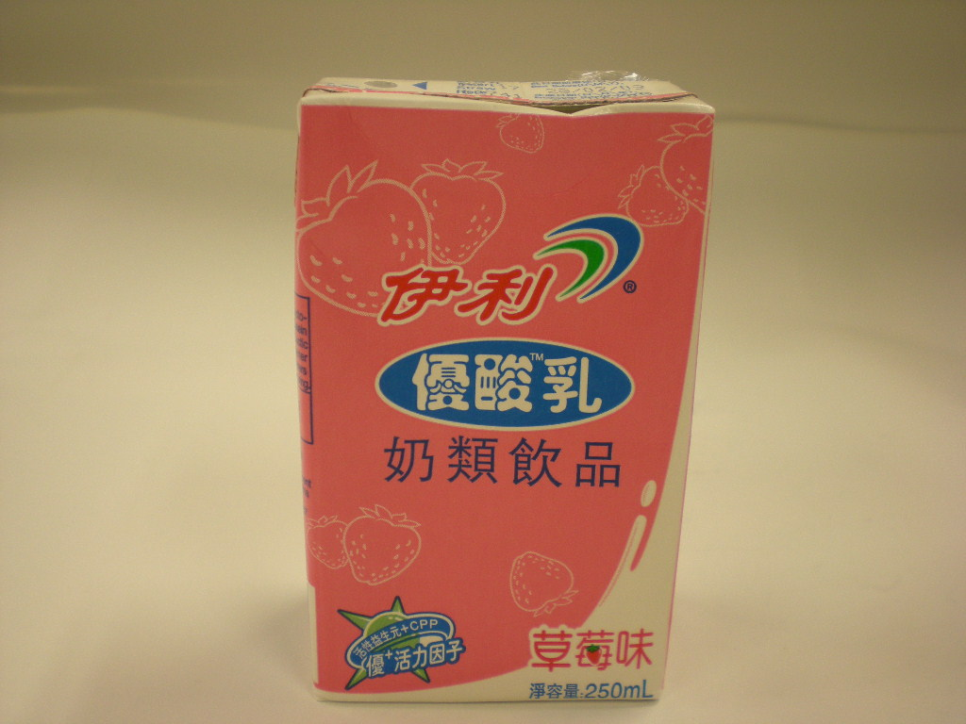
3 | Yili Bean Club- Red bean milk bar  伊利佰豆集 牛奶蜜豆(雪條)  (淨體積: 95毫升)  (Expiry date: 2.6.2010) | Manufacturer: Shanghai Yili AB Foods Co., Ltd  Address: No. 269 Beidou Road, Minhang Zone, Shanghai P.R. of China | 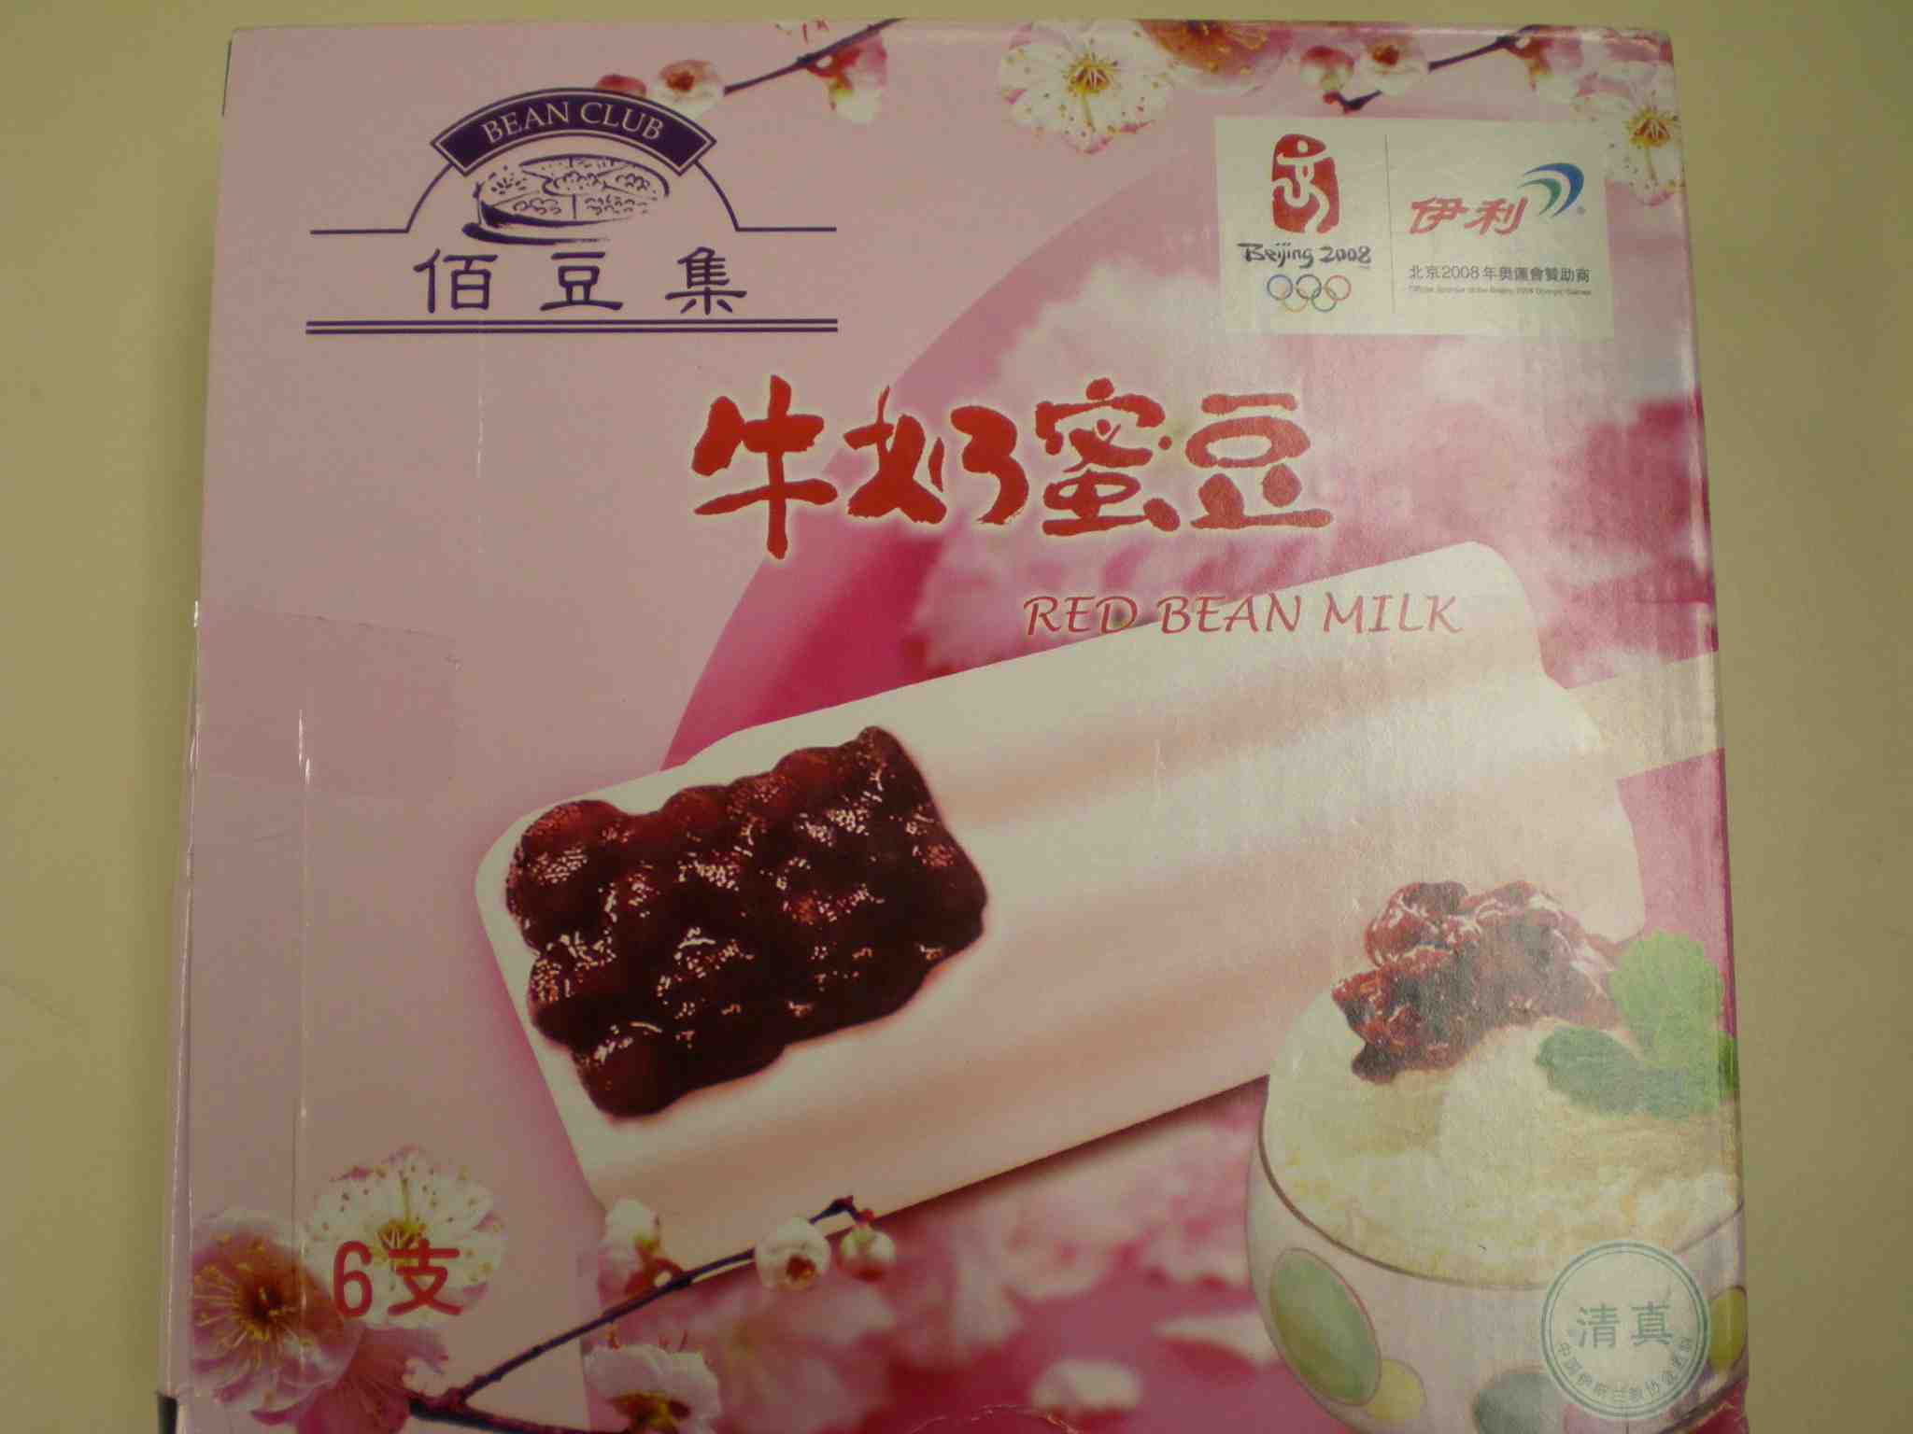
4 | Yili Chocliz crispy chocolate bar  伊利巧樂茲朱古力脆棒(雪糕)  (淨體積: 100毫升)  (Expiry date: 1.6.2010) | Manufacturer: Shanghai Yili AB Foods Co., Ltd  Address: No. 269 Beidou Road, Minhang Zone, Shanghai P.R. of China | 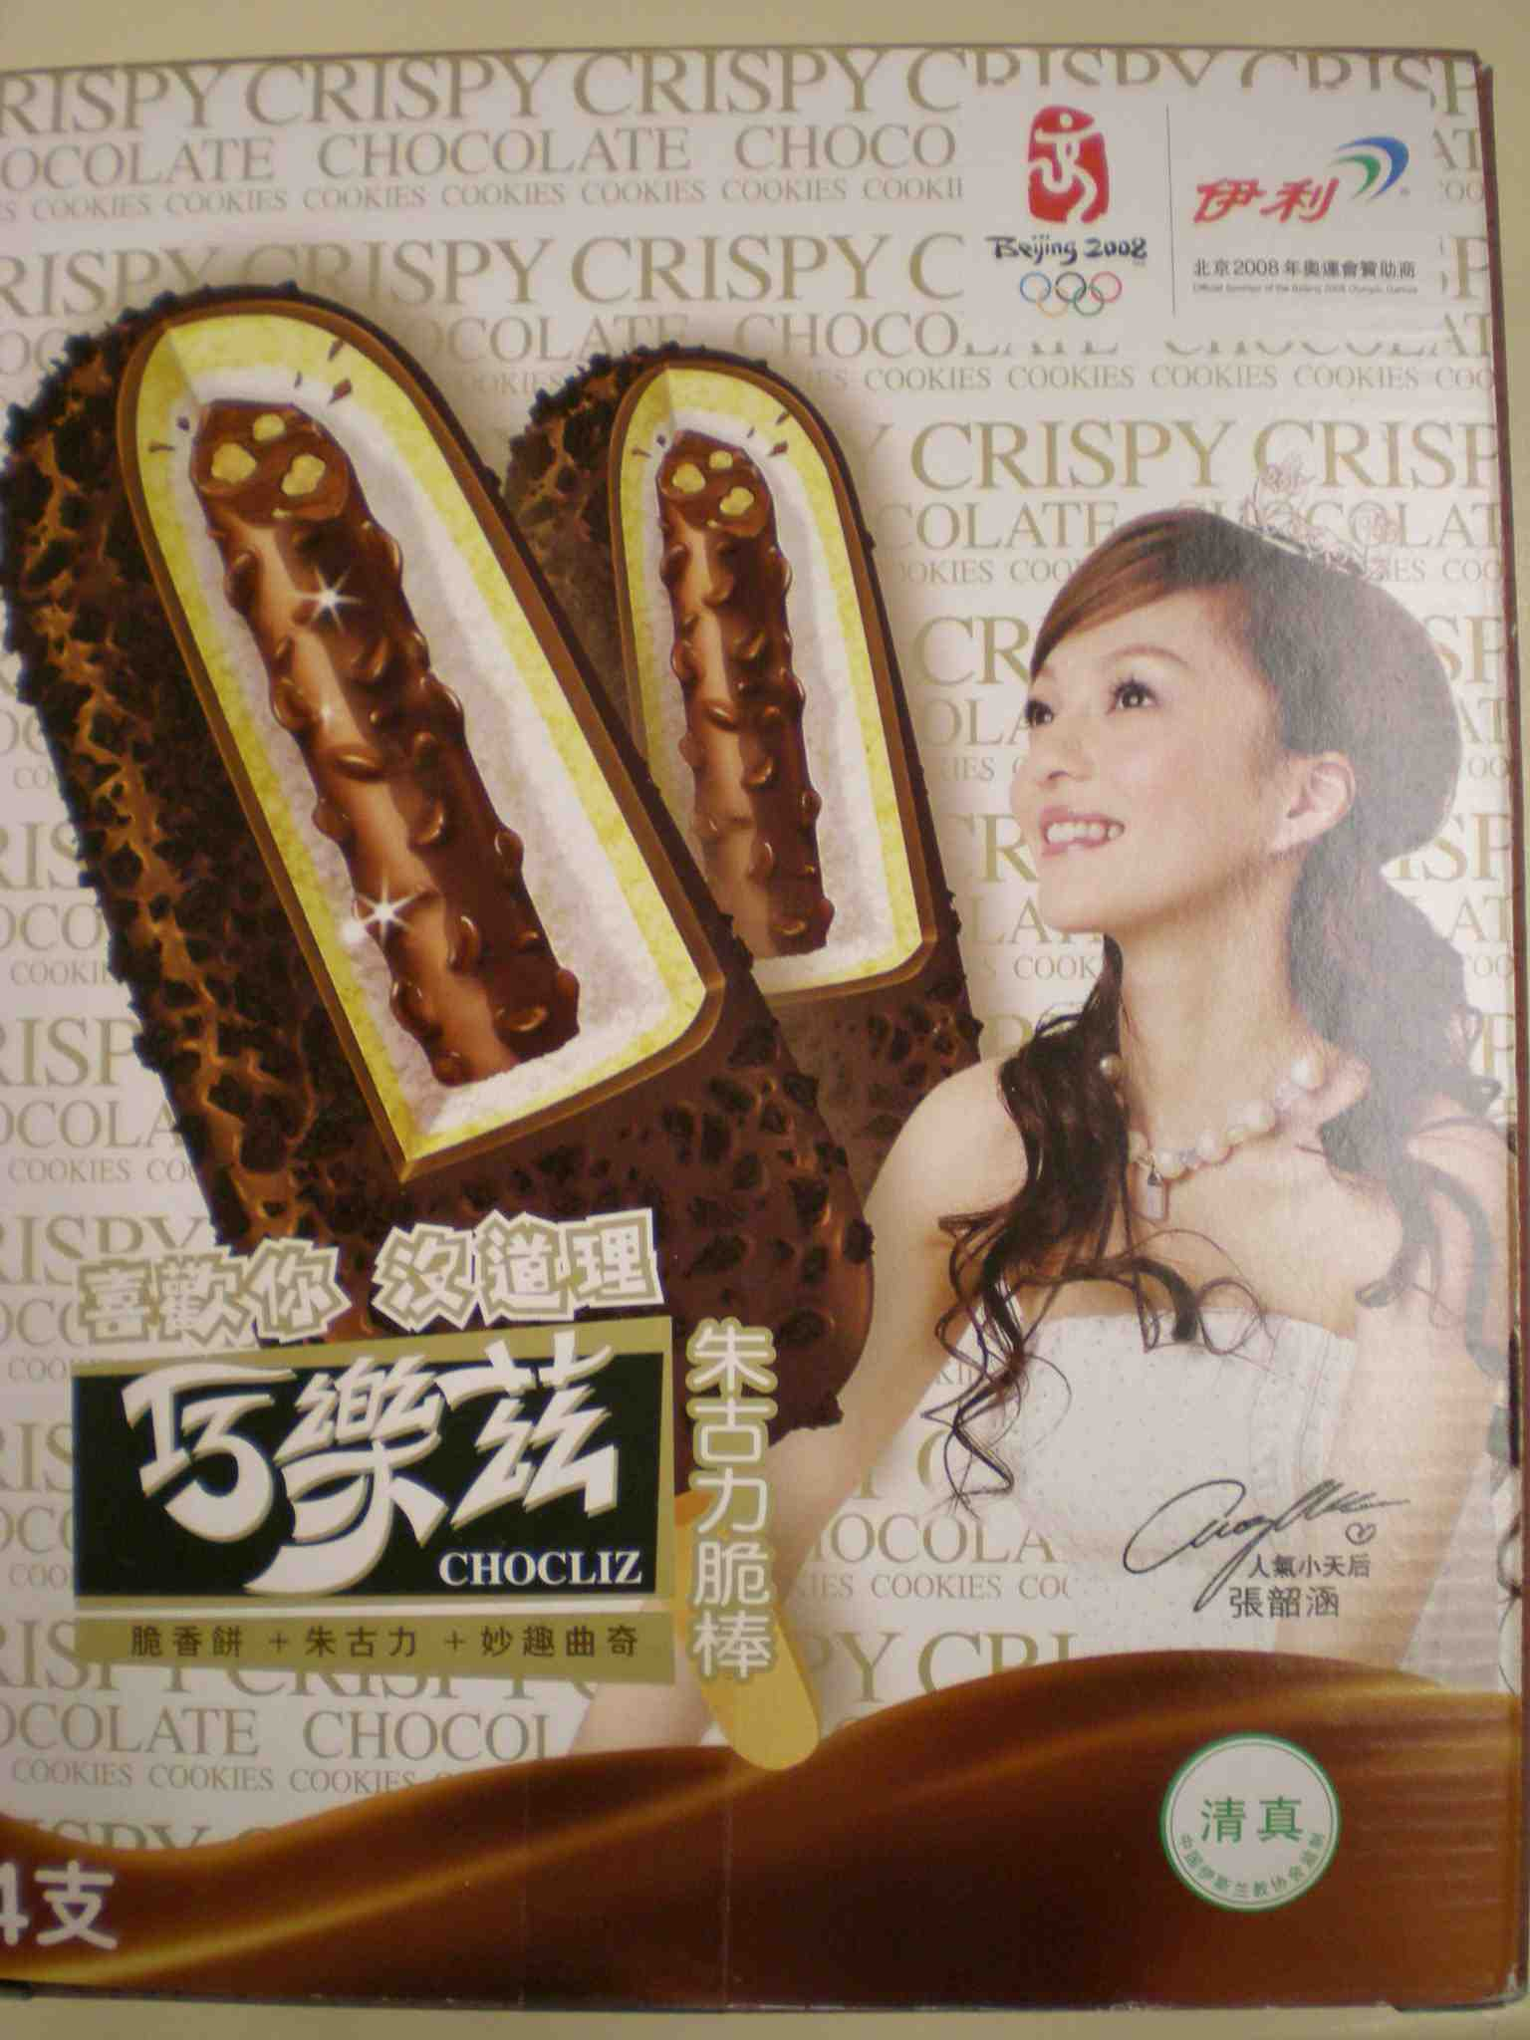
5 | Yili Tri-color cup  伊利三色杯(雪糕)  (淨體積: 250毫升)  (Expiry date: 6.6.2010) | Manufacturer: Shanghai Yili AB Foods Co., Ltd  Address: No. 269 Beidou Road, Minhang Zone, Shanghai P.R. of China | 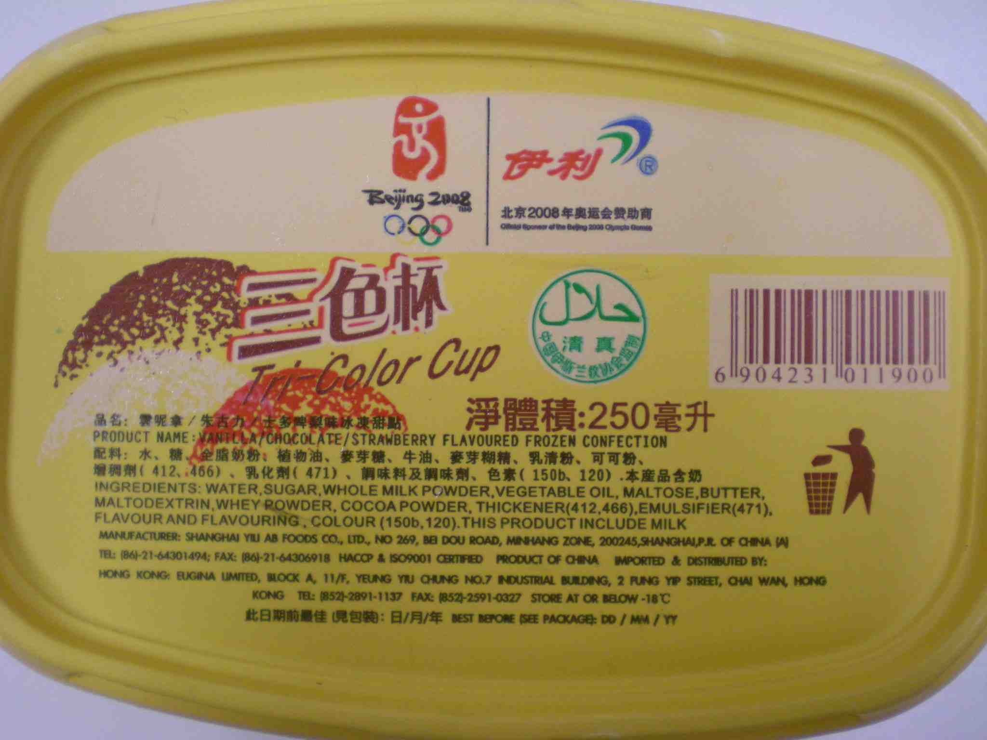
6 | Yili Pure Milk  伊利純牛奶  (淨體積: 250毫升)  (Expiry date: 6.2.2009) | Manufacturer: Inner Mongolia Yili Industrial Group Co., Ltd.  內蒙古伊利實業集團股份有限公司  Address: No.2, Jin 3 Ave, Jinchuan Development Zone, Hohhot, Inner Mongolia, China  中國內蒙古呼和浩特市金川開發區金三道2號 | 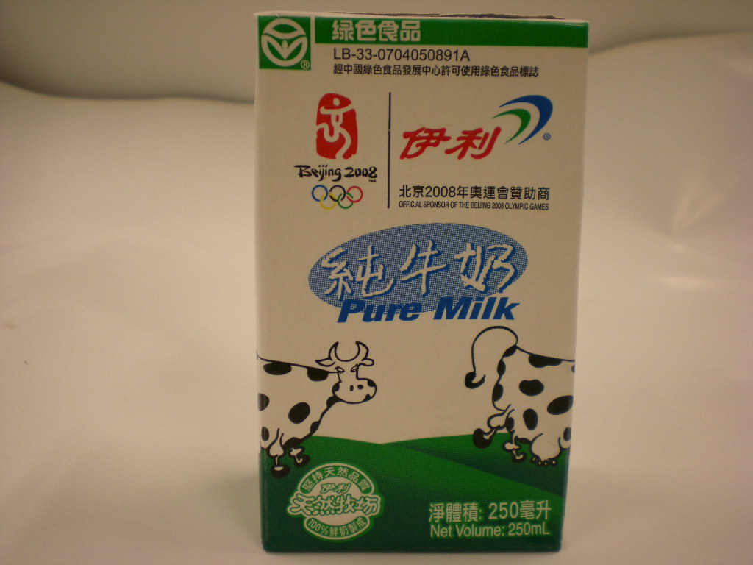
7 | Yili Pure Milk  伊利純牛奶  (淨體積: 1公升)  (Expiry date: 12.12.2008) | Manufacturer: Inner Mongolia Yili Industrial Group Co., Ltd.  內蒙古伊利實業集團股份有限公司  Address: No.2, Jin 3 Ave, Jinchuan Development Zone, Hohhot, Inner Mongolia, China  中國內蒙古呼和浩特市金川開發區金三道2號 | 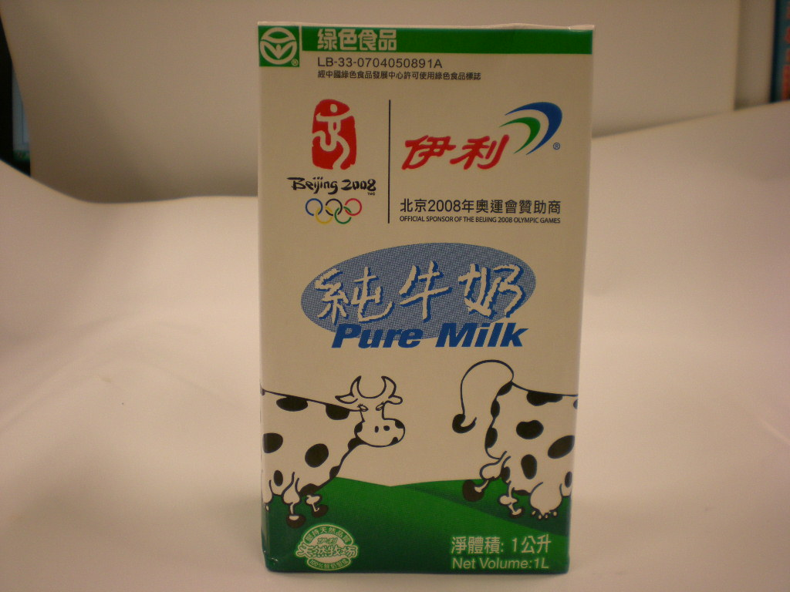
8 | Yili Natural Choice Ice cream – Yogurt  伊利牧場特品酸奶味(雪糕)  (淨體積: 450毫升)  (Expiry date: 14.3.2010) | Manufacturer: Shanghai Yili AB Foods Co., Ltd  Address: No. 269 Beidou Road, Minhang Zone, Shanghai P.R. of China | 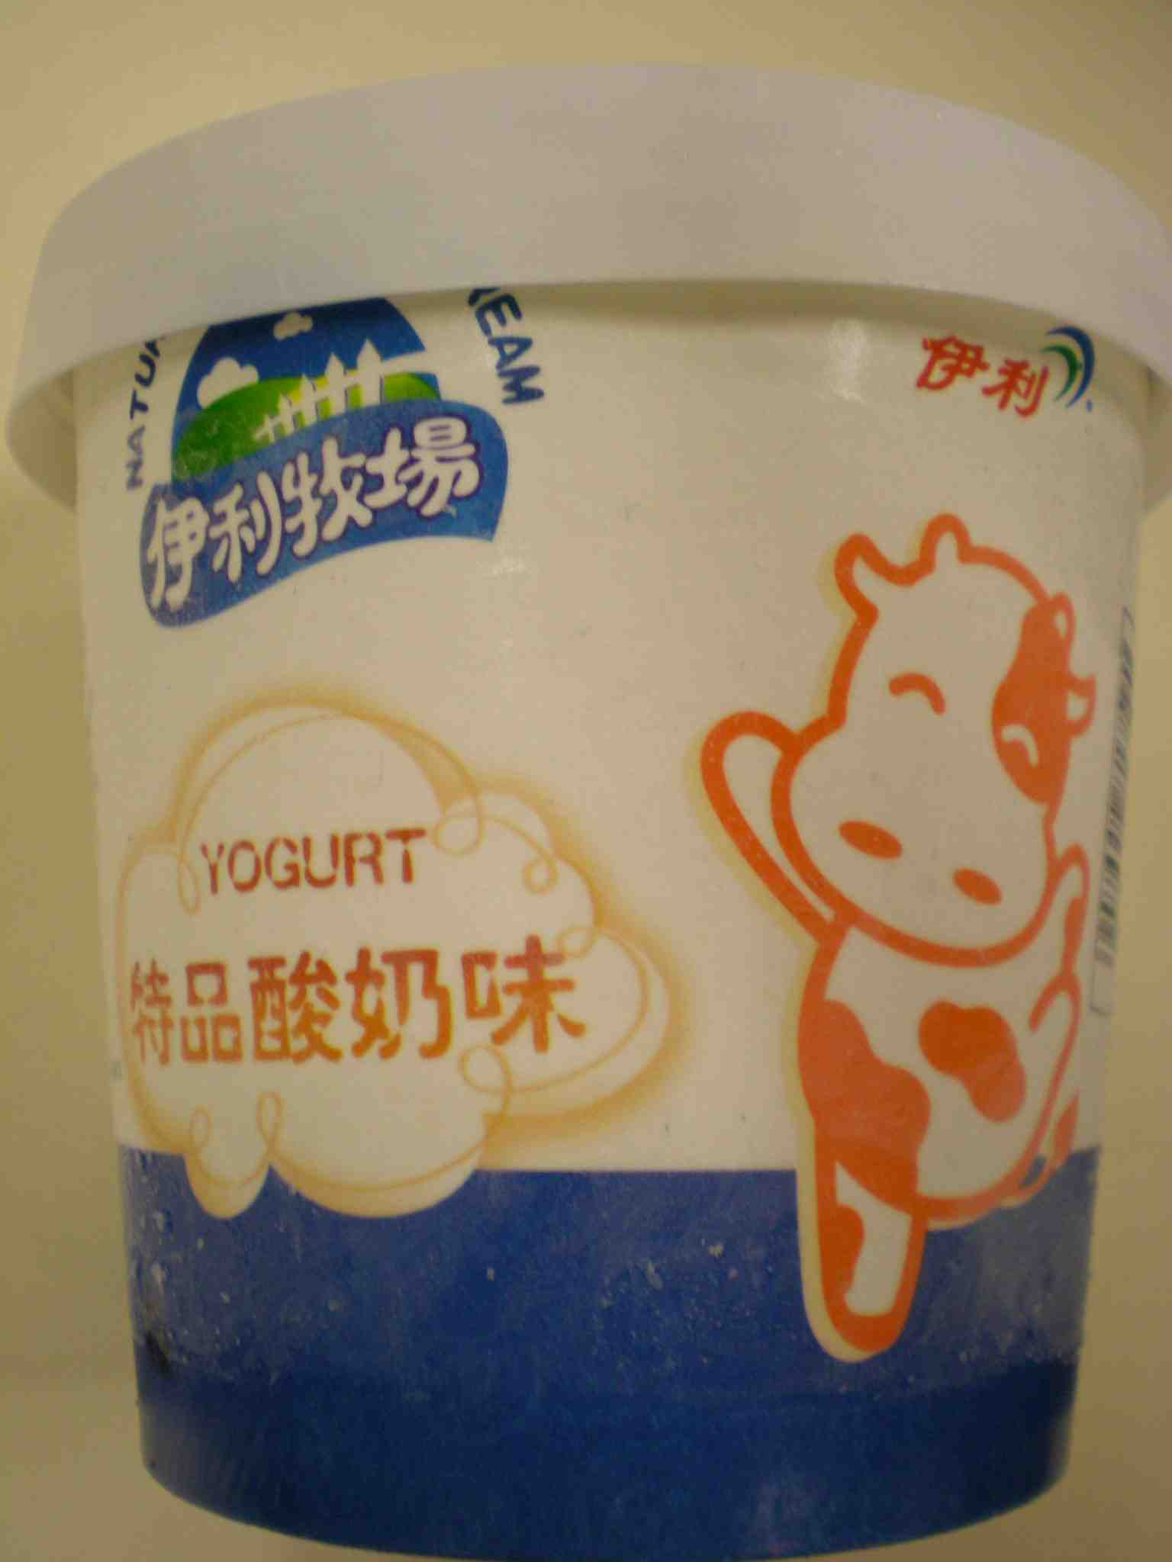
9 | Yili Bean Club- Matcha red bean ice bar  伊利佰豆集 抹茶紅豆(雪條)  (淨體積: 87毫升)  (Expiry date: 6.5.2010) | Manufacturer: Shanghai Yili AB Foods Co., Ltd  Address: No. 269 Beidou Road, Minhang Zone, Shanghai P.R. of China | 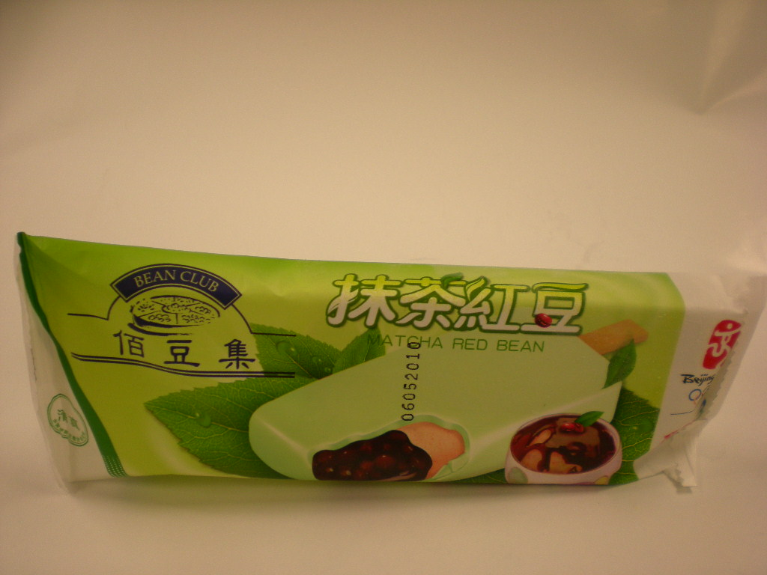
10 | Yili Chocliz crispy chocolate bar  伊利巧樂茲朱古力脆棒(雪糕)  (淨體積: 100毫升)  (Expiry date: 1.7.2010) | Manufacturer: Shanghai Yili AB Foods Co., Ltd  Address: No. 269 Beidou Road, Minhang Zone, Shanghai P.R. of China | 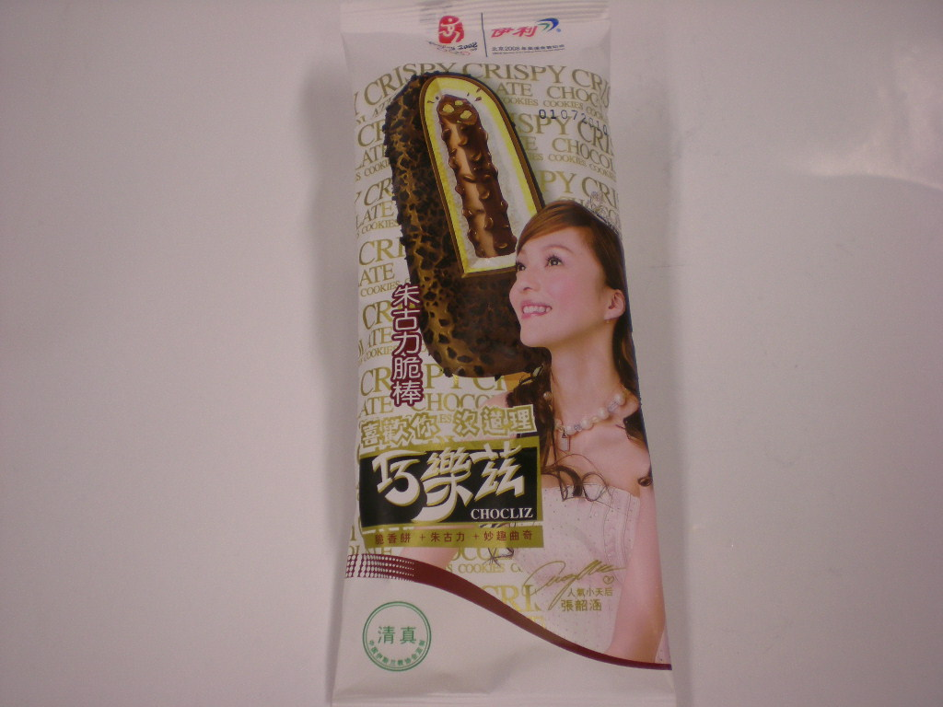
11 | Yili Natural choice milk bar – milk flavour  伊利牧場香濃布丁(雪條)  (淨體積: 85毫升)  (Expiry date: 3.7.2010) | Manufacturer: Shanghai Yili AB Foods Co., Ltd  Address: No. 269 Beidou Road, Minhang Zone, Shanghai P.R. of China | 