Appendix IV

2008 Prestige Annual Stamp Album
and 2008 Annual Stamp Pack

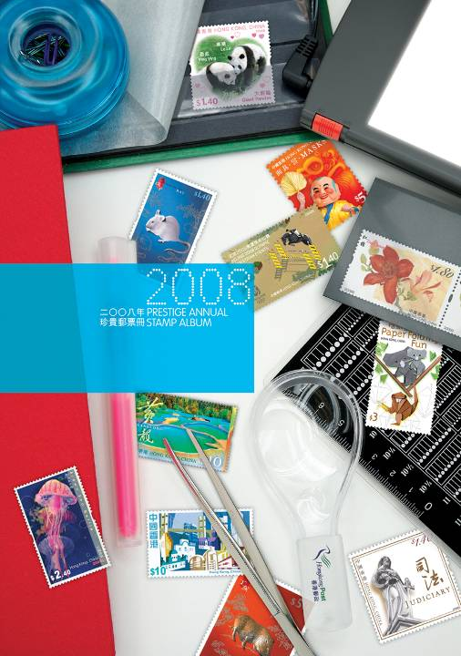
Slip Case Album

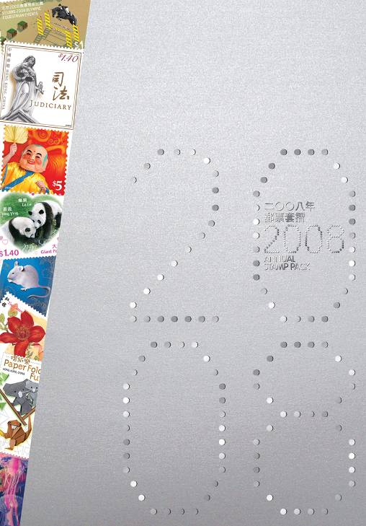
2008 Annual Stamp Pack

