Appendix 2

Summary of Updated Projections for Rainfall
in the 21st Century by the Hong Kong Observatory

In the light of the latest global projections in the Fourth Assessment Report (AR4) of the Intergovernmental Panel on Climate Change (IPCC) published in 2007, the Hong Kong Observatory has updated its projections for rainfall in Hong Kong in the 21st century. This is a follow-up to the initial study carried out in 2005, based on the projections presented in the Third Assessment Report (TAR) of IPCC.

The computations are based on projected global scenarios of economic and social development, which would result in different amounts of greenhouse gases being emitted into the atmosphere. Information on the data used and the scenarios adopted by IPCC are given in Annex.

The updated rainfall projection results for Hong Kong in the 21st century are summarised below:

- Increase in annual rainfall

The average annual rainfall in Hong Kong will increase during the latter half of the 21st century.

It is anticipated that by the last decade of the 21st century, that is, during the decade 2090-2099, the average annual rainfall at the Hong Kong Observatory Headquarters (HKOHq) would be about 2572 mm, or 248 mm (i.e. +11%) above the average of 2324 mm for the last two decades of the 20th century (1980-1999). Please see attached figure.

- More extremely wet and dry years

The number of extremely wet years (annual rainfall at HKOHq above 3187 mm) and extremely dry years (annual rainfall at HKOHq below 1282 mm) will increase.

The number of extremely wet years will increase significantly from 3 during the period 1885-2008 to 10 in the 21st century and the corresponding figure for extremely dry years is also expected to increase from 2 to 4.

- More heavy rain days

During the last 30 years of this century, that is 2070-2099, the average number of days in a year with hourly rainfall at HKOHq exceeding 30 mm would be about 6.5 days, about 1 day more than the 1980-1999 average of 5.8 days.

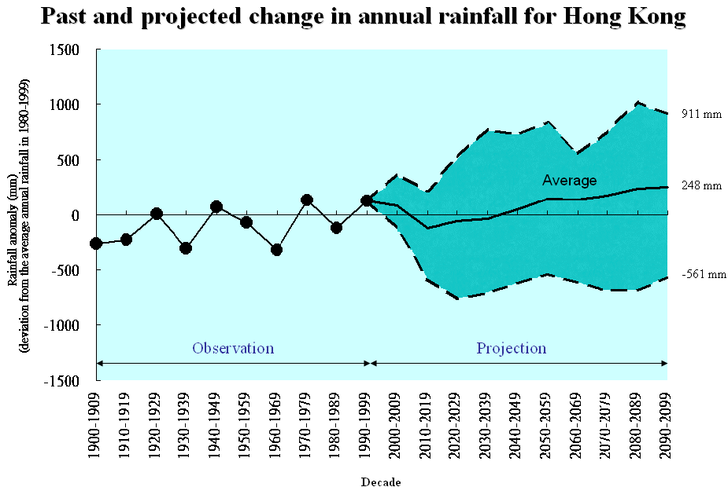
The increase in average annual rainfall, number of heavy rain days, and year-to-year rainfall variability in Hong Kong in the 21st century as depicted in this projection are consistent with the previous results based on TAR. A scientific paper discussing the revised projections in detail is available online at http://www.weather.gov.hk/publica/reprint/r798.pdf.

Annex

IPCC Greenhouse Gas Emission Scenarios

In order to make a projection of the future climate, it is necessary to develop scenarios regarding the emission of greenhouse gases into the atmosphere. Future greenhouse gas emissions are dependent on many factors such as population growth, socio-economical development, technological advancement, etc. In the Fourth Assessment Report (AR4) of the Intergovernmental Panel on Climate Change (IPCC), six emission scenarios for greenhouse gases are employed. The six scenarios in order of descending greenhouse gas emission are: A1FI, A2, A1B, B2, A1T and B1. For IPCC AR4, model projection data is available for the A2, A1B and B1 scenarios and all available data is used in the latest projection of rainfall for Hong Kong in the 21st century.

Detailed descriptions of these emission scenarios are available at the IPCC website: http://www.ipcc.ch/pdf/special-reports/spm/sres-en.pdf. The scenarios as portrayed in the website are outlined below:

- The A1 storyline and scenario family describes a future world of very rapid economic growth, global population that peaks in mid-century and declines thereafter, and the rapid introduction of new and more efficient technologies. Major underlying themes are convergence among regions, capacity building, and increased cultural and social interactions, with a substantial reduction in regional differences in per capita income. The A1 scenario family develops into three groups that describe alternative directions of technological change in the energy system. The three A1 groups are distinguished by their technological emphasis: fossil intensive (A1FI), non-fossil energy sources (A1T), or a balance across all sources (A1B) (where balanced is defined as not relying too heavily on one particular energy source, on the assumption that similar improvement rates apply to all energy supply and end use technologies).

- The A2 storyline and scenario family describes a very heterogeneous world. The underlying theme is self-reliance and preservation of local identities. Fertility patterns across regions converge very slowly, which results in continuously increasing global population. Economic development is primarily regionally oriented and per capita economic growth and technological change are more fragmented and slower than in other storylines.

- The B1 storyline and scenario family describes a convergent world with the same global population that peaks in mid century and declines thereafter, as in the A1 storyline, but with rapid changes in economic structures toward a service and information economy, with reductions in material intensity, and the introduction of clean and resource-efficient technologies. The emphasis is on global solutions to economic, social, and environmental sustainability, including improved equity, but without additional climate initiatives.

- The B2 storyline and scenario family describes a world in which the emphasis is on local solutions to economic, social, and environmental sustainability. It is a world with continuously increasing global population at a rate lower than A2, intermediate levels of economic development, and less rapid and more diverse technological change than in the B1 and A1 storylines. While the scenario is also oriented toward environmental protection and social equity, it focuses on local and regional levels.

