ANNEX (P.1)
- Daily Theme Postmarks & Special Postmarks

Date | Daily Theme Postmark | Special Postmark
14 May 2009 | 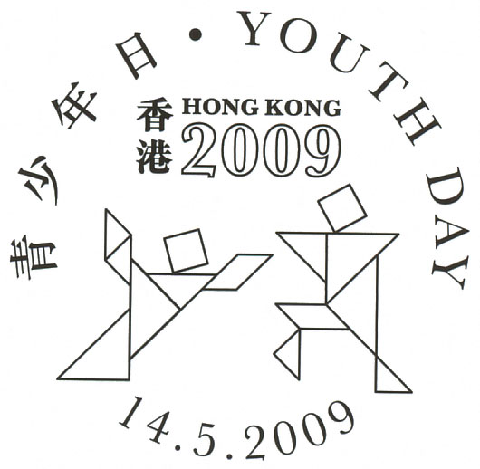  “Youth Day” | 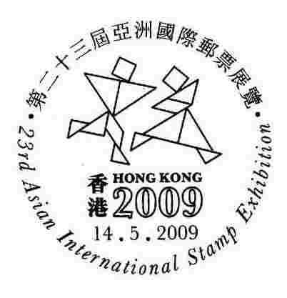  “HONG KONG 2009 – 23rd Asian International Exhibition”
15 May 2009 | 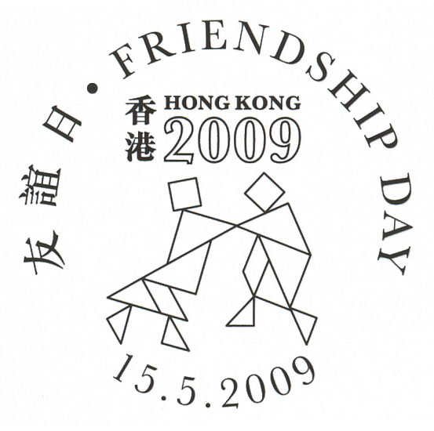  “Friendship Day” | -
16 May 2009 | 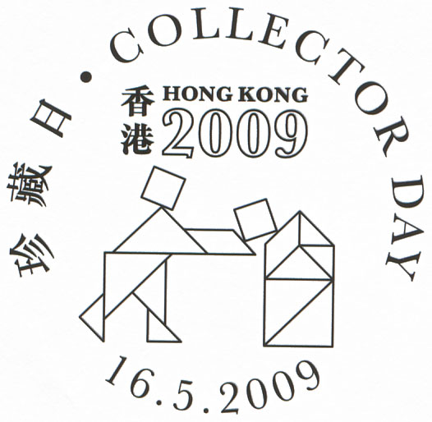  “Collector Day” | 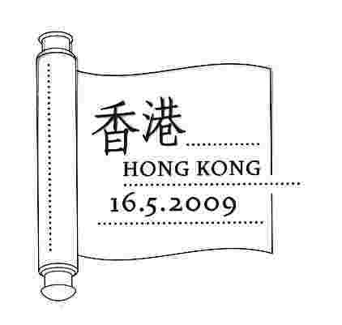  “Hong Kong Museums Collection”
17 May 2009 | 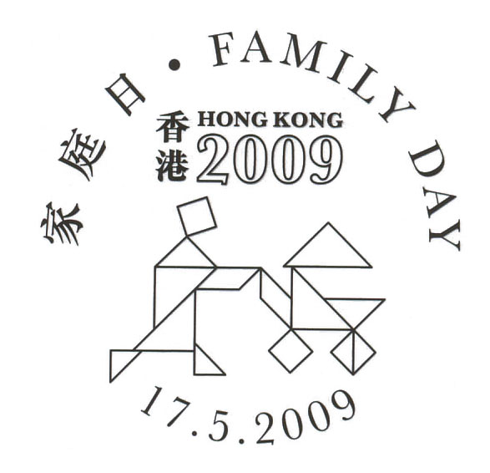  “Family Day” | -

ANNEX (P.2)

2. Temporary Post Office

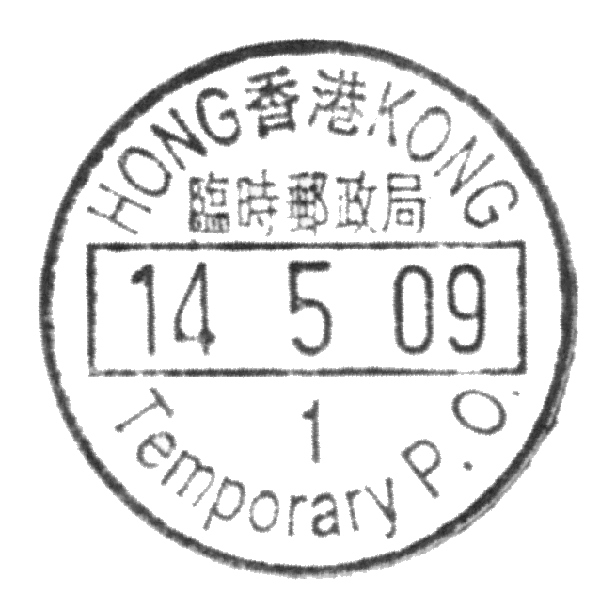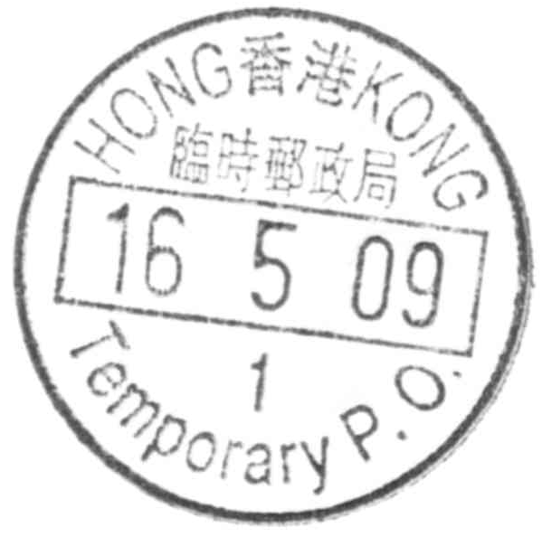

3. Cachets

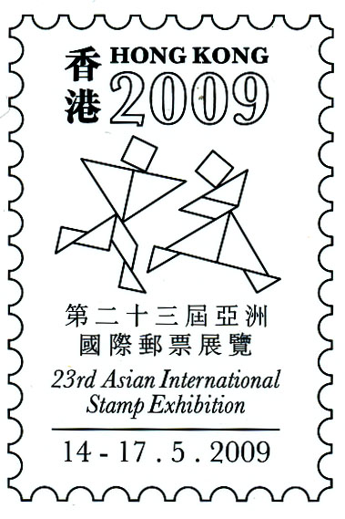 | 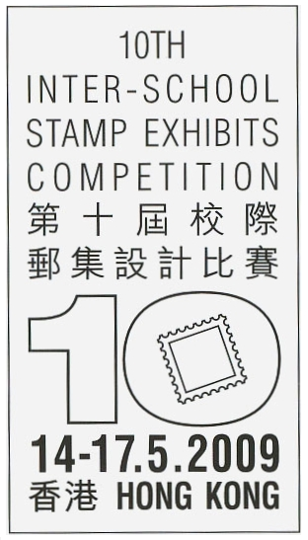
HONG KONG 2009 –  23rd Asian International Stamp Exhibition | 10th Inter-School Stamp Exhibits Competition

- END -

