Appendix 2

Image of 4 stamp panes for “Heartwarming Stamps Customised Service (2009 version)”
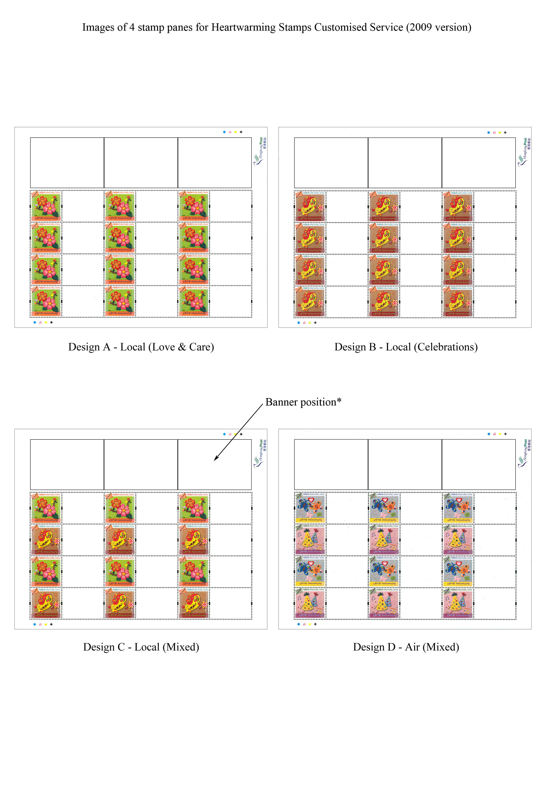

(* Maximum of 3 images can be placed on the banner position at the top of the stamp pane.)

