HK/Mainland Gift Fulfillment Service – 2009 Mid-Autumn Festival Gift Sets
(Ordering Date：3.9.2009 - 23.9.2009)

Gift Sets from Hong Kong

“Kee Wah” Mooncake Gift Sets
Gift’s Name | Details | Gift’s Code |  | Unite Price  (HK$) | Image
White Lotus Seed Paste Mini Mooncakes with Half Yolk | 8 pieces per box | To Mainland | KW09CN_1 | $208 | 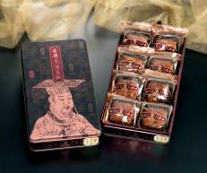
White Lotus Seed Paste Mini Mooncakes with Half Yolk | 8 pieces per box | To Hong Kong | KW09HK_1 | $178
White Lotus Seed Paste Mini Mooncakes with Half Yolk | 8 pieces per box | To Macao | KW09MO_1 | $188
White Lotus Seed Paste Mini Mooncakes with Half Yolk | 8 pieces per box | To US / Canada | KW09US_1* | $358
Assorted Gift Box | - Golden Lotus Seed Paste Mooncake with Two Yolks X1  - Mini White Lotus Seed Paste Mooncake with Half Yolk x 1  - Mini Golden Lotus Seed Paste Mooncake with Half Yolk x 1  - Mini Chinese Ham Mooncake x 1  - Mini Pineapple Paste Mooncake with Half Yolk x 1  - Mini Black Date Paste Mooncake x 1  - Mini Walnut and Coconut Paste Mooncake x 1  - Mini Green Bean Paste Mooncake with Mixed Yolk x 1  - Mini Red Bean Paste Mooncake with Half Yolk x 1 | To Mainland | KW09CN_2 | $288 | 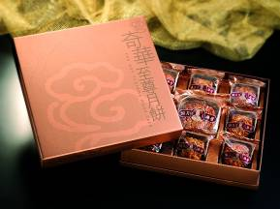
Assorted Gift Box |  | To Hong Kong | KW09HK_2 | $238
Assorted Gift Box |  | To Macao | KW09MO_2 | $248
Assorted Gift Box |  | To US / Canada | KW09US_2* | $468
White Lotus Seed Paste Mooncakes with Two Yolks | 4 pieces per box | To Mainland | KW09CN_3 | $298 | 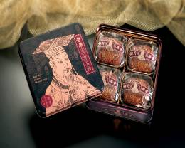
White Lotus Seed Paste Mooncakes with Two Yolks | 4 pieces per box | To Hong Kong | KW09HK_3 | $268
White Lotus Seed Paste Mooncakes with Two Yolks | 4 pieces per box | To Macao | KW09MO_3 | $268
White Lotus Seed Paste Mooncakes with Two Yolks | 4 pieces per box | To US / Canada | KW09US_3* | $468
Royal Gift Box | - Golden Lotus Seed Paste Mooncakes x 2  - White Lotus Seed Paste Mooncake with Two Yolks x 2  - Mooncake with Chinese Ham x 2 | To Mainland | KW09CN_4 | $428 | 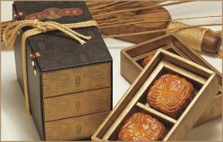
Royal Gift Box |  | To Hong Kong | KW09HK_4 | $388
Royal Gift Box |  | To Macao | KW09MO_4 | $388
Royal Gift Box |  | To US / Canada | KW09US_4* | $578
“Wing Wah” Mooncake Gift Sets
Gift’s Name | Details | Gift’s Code |  | Unite Price  (HK$) | Image
White Lotus Seed Paste Mooncake with Two Yolks | 4 pieces per box | To Mainland | WH09CN_1 | $328 | 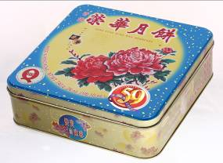
White Lotus Seed Paste Mooncake with Two Yolks | 4 pieces per box | To Hong Kong | WH09HK_1 | $288
White Lotus Seed Paste Mooncake with Two Yolks | 4 pieces per box | To Macao | WH09MO_1 | $288
White Lotus Seed Paste Mooncake with Two Yolks | 4 pieces per box | To US / Canada | WH09US_1* | $418
Mini Assorted Mooncakes | - White Lotus Seed Paste Mooncake with Three Yolks x 1  - Mini White Lotus Seed Paste Mooncake with Half Yolk x 7 | To Mainland | WH09CN_2 | $388 | 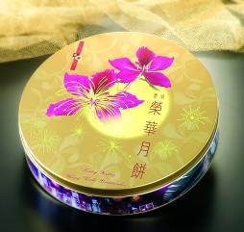
Mini Assorted Mooncakes |  | To Hong Kong | WH09HK_2 | $348
Mini Assorted Mooncakes |  | To Macao | WH09MO_2 | $348
Mini Assorted Mooncakes |  | To US / Canada | WH09US_2* | $528

* The option of delivery to United States or Canada is available online (www.shopthrupost.hk) ONLY.

Selected by China Post, Made in China

“Guangdong” Mooncake Gift Sets
Gift’s Name | Details | Gift’s Code |  | Unite Price  (HK$) | Image
Lotus Seed Paste Mooncakes with One Yolk | 4 pieces per box | To Mainland | GD09CN_1 | $168 | 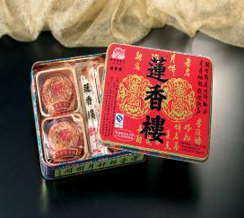
Deluxe Mini Assorted Mooncakes | - White Lotus Seed Paste Mooncake with Yolk x 1  - Golden Lotus Seed Paste Mooncakes with Yolk x 2  - Red Bean Paste Mooncakes x 3  - Mooncakes with Mixed Nuts x 2 | To Mainland | GD09CN_2 | $228 | 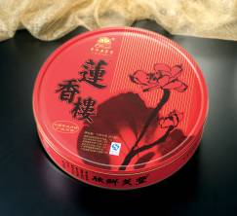
Mini Mochi Mooncakes | - Strawberry favor mooncake X 2  - Grape favor mooncake x 2  - Mango favor mooncake x 2  - Coconut favor mooncake x 2  - Honey dew favor mooncake x 2 | To Mainland | GD09CN_3 | $168 | 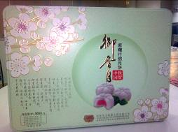
“Chiu Chow” Mooncake Gift Sets
Gift’s Name | Details | Gift’s Code |  | Unite Price  (HK$) | Image
Chiu Chow Style Assorted Mooncakes | - Black Bean Paste Mooncakes x 2  - Green Bean Paste Mooncakes x 2 | To Mainland | GD09CN_4 | $168 | 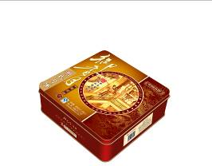
Chiu Chow Style Vegetarian Mooncakes | - Xylitol Black Bean Paste Mooncakes x 3  - Xylitol Green Bean Paste Mooncakes x 6 | To Mainland | GD09CN_5 | $228 | 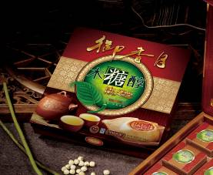

Made in Japan

Japanese Mooncake Gift Sets (AVAILABLE AT SHOPTHRUPOST ONLY)
Gift’s Name | Details | Gift’s Code |  | Unite Price  (HK$) | Image
Custard Cream Cake | 8 pieces per box | To Mainland | YT08HK_1 | $268 | 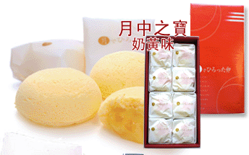
Custard Cream Cake | 8 pieces per box | To Hong Kong | YT09HK_1 | $228
Custard Cream Cake | 8 pieces per box | To Macao | YT09MO_1 | $228
Green Tea & Red Bean Custard Cream Cake | 8 pieces per box | To Mainland | YT09CN_2 | $268 | 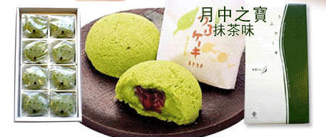
Green Tea & Red Bean Custard Cream Cake | 8 pieces per box | To Hong Kong | YT09HK_2 | $228
Green Tea & Red Bean Custard Cream Cake | 8 pieces per box | To Macao | YT09MO_2 | $228
Milk Cream Paste Cake | 6 pieces per box | To Mainland | YT09CN_3 | $218 | 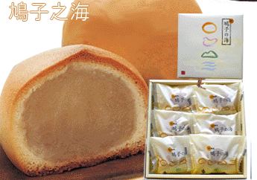
Milk Cream Paste Cake | 6 pieces per box | To Hong Kong | YT09HK_3 | $168
Milk Cream Paste Cake | 6 pieces per box | To Macao | YT09MO_3 | $168

