Annex I
附件一

List of Adjudicators
評審團成員

I. Chinese Painting /Seal-carving
中國書畫及篆刻

Local Adjudicators:
本地評審:

Mr. Huang Junshi (黃君實先生) | 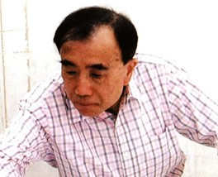
Calligrapher; Connoisseur
Dr. Tong Kam-tang (唐錦騰博士) | 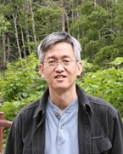
Calligrapher, Painter and Seal engraver; Associate Professor of Fine Arts Department, The Chinese University of Hong Kong
Mr. Tsang Kwong-choi (曾廣才先生) | 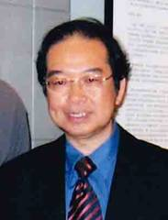
Calligrapher; Expert Adviser of Leisure and Cultural Services Department

Adjudicators from the Mainland and Overseas:
本地及海外評審:

Mr. Pi Daojian (皮道堅先生) | 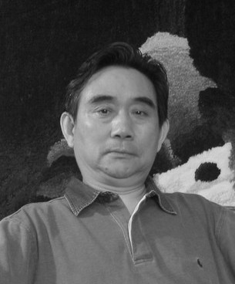

Professor of Southern China Normal University, Guangzhou, China
Mr. Wang Tiande (王天德先生) | 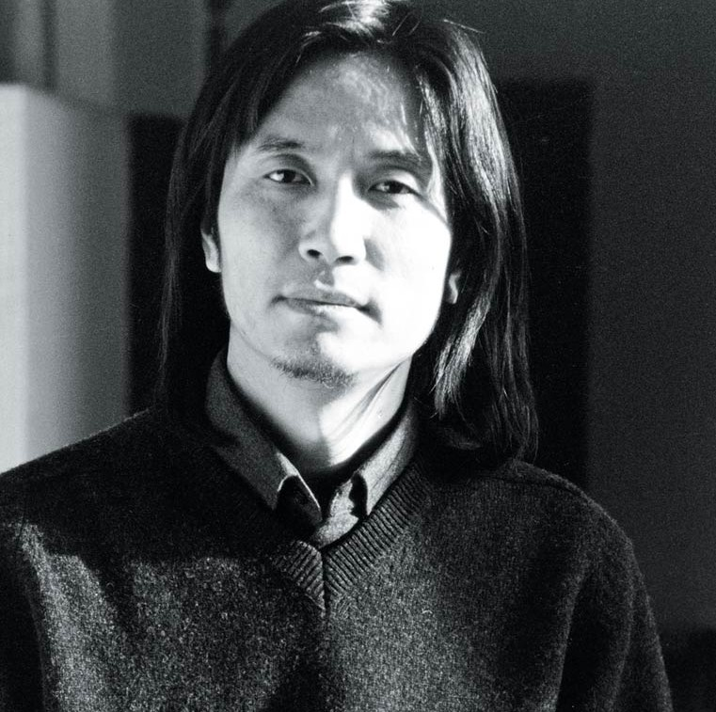

Professor of Art Education Centre, Fudan University, Shanghai, China

II. Western Media
西方媒介

Local Adjudicators:
本地評審
Mr. Cheung Yee (張義先生) | 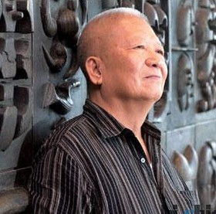
Sculptor; Printmaker; Expert Adviser of Leisure and Cultural Services Department
Ms. Cho Yeou-jui (卓有瑞女士) | 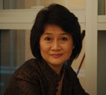
Artist; Artist-in-residence, Assistant professor, Academy of Visual Arts, Hong Kong Baptist University
Ms. Jane DeBevoise | 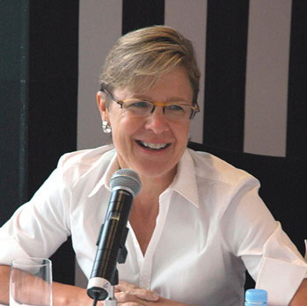
Chair of the Asia Art Archive
Mr. Ko Wah-man, Norman (高華文先生) | 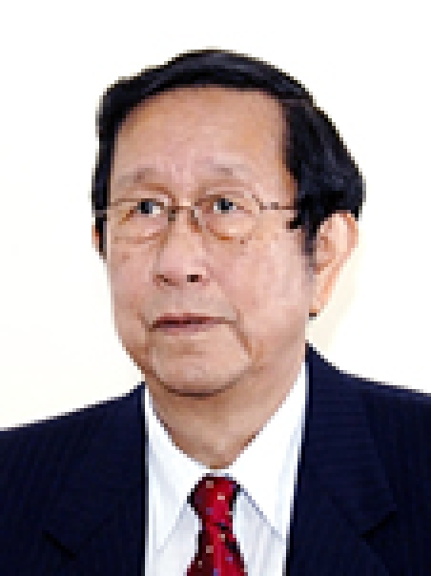
Sculptor; Emeritus Professor of Department of Mechanical Engineering, The University of Hong Kong
Ms. Leung Mee-ping (梁美萍女士) | 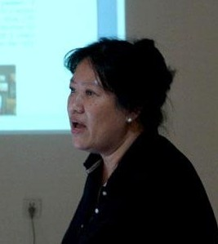
Installation artist; Independent curator; Lecturer of Academy of Visual Arts, Hong Kong Baptist University
Ms. Wong Wo-bik (王禾壁女士) | 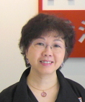
Photographer; Manager of Arts Support Division, Hong Kong Arts Development Council; Expert Adviser of Leisure and Cultural Services Department

Adjudicators from the Mainland and Overseas:
海外 / 內地評審:
Ms. Binghui Huangfu (皇甫秉惠女士) | 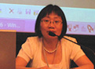
Deputy Director of Zendai MoMA, Shanghai
Mr. Scott Burnham | 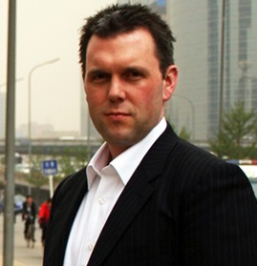
Independent curator
Mr. Fei Dawei (費大為先生) | 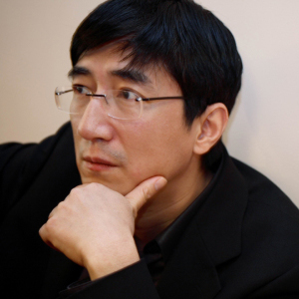
Dean of Ullens Fund; Art critic
Mr. Fumio Nanjo (南條史生先生) | 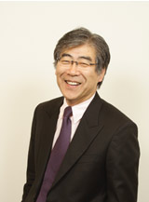
Director of Mori Art Museum

