Open Group Grand Award Winner

火花
宇宙萬物的創造源於一點火花。以火花比喻一切創作活動，最為貼切。創作往往始於電光石火的靈感湧現、忽有所悟，亦即讓創作人驚歎“我想到了”的一剎。上圖的火花標誌，表示香港是一個能點燃無限創意的地方。三點火花代表主要的靈感泉源，即天、地和人；思想、身體和靈魂；知性、感性和靈性。這些都是一切創作活動的基礎。

SPARKS

A SPARK initiated that first moment of CREATION on our planet, this is an apt analogy for all CREATIVE endeavours which all begin with a SPARK, a sudden inspired moment, an instant of insight, what creatives call that EUREKA moment.

Visualized here are SPARKS communicating Hong Kong as that place where ideas are SPARKED. The three SPARKS connote the main sources of our inspirations: HEAVEN, EARTH and MAN; MIND, BODY and SOUL; and INTELLECT, EMOTION and SPIRIT which are the basis of all creative endeavours.
Student Group Grand Award Winner

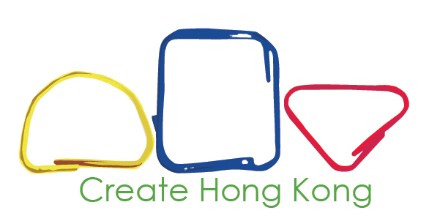

創意處處

我的設計靈感來自潛藏四周的創意。
我用了簡單的線條帶出香港的本土設計可以無限延伸，線條所包圍的空白代表香港由我們創造。我採用了黃、藍、紅這三原色，奪目的顏色代表香港設計的吸引力。
另外，設計中的圓形代表香港不同的建築，因為建築是香港創意產業的重要元素。

Around

Creative ideas are everywhere around us, and this is where my concept begins.

I use simple lines to Hong Kong‘s local design, which can be extended infinitely. The white space means Hong Kong is created by us. I use the three fundamental colours, i.e. yellow, blue and red, to demonstrate the attractiveness of Hong Kong designs.

Moreover, the shapes also represent different architectures as architecture is also one important sector of creative industries.

