Diagram: Partial eclipse of the sun on January 15, 2010

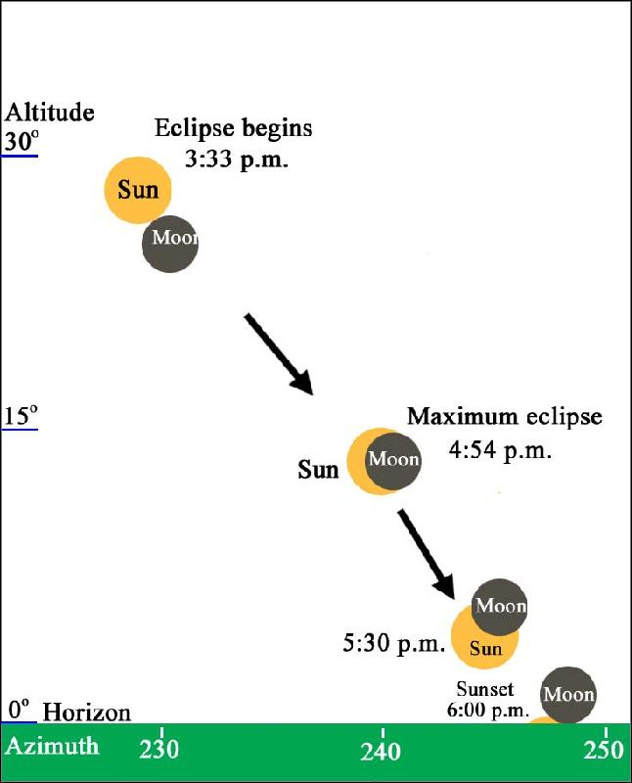

(The above diagram is for illustrative purpose only. Sizes of the sun and the moon are not drawn to the scale of the background.)

