APPENDIX 1

Mainland-Hong Kong-Macao Gift Fulfillment Service
New Gift Sets for Lunar New Year 2010

中國郵政賀年禮品系列 (中國供應) / Gift sets provided by China Post (Made in China)
皆大歡喜  Assorted Gift Set  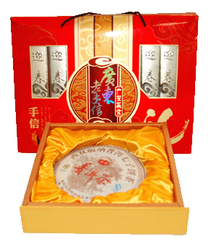 | GD10CN1 (內地派遞): $288  GD10HK1 (香港派遞): $388  GD10MO1 (澳門派遞) $388
 | 廣式臘腸(454克)、陽春黃皮甘(200克)、中山杏仁餅(200克)、客家薑糖(180克)、廣東核桃酥(220克)、梅州柚皮(186克)、德慶首烏糖(280克)、佛山盲公餅(200克)、廣東雞仔餅(200克)、潮州豆坊酥(200克)、免費贈送尚崗普洱茶一盒(357克) | Guangdong Style Preserved Meat Sausages (454g), Yangchun Preserved Wangpee (200g), Zhongshan Almond Cakes (200g), Hakka Ginger Candies (180g), Guangdong Walnut Pastries (220g), Meizhou Pomelo Peels (186g), Deqing Fleeceflower Root Candies (280g), Foshan Manggong Cakes (200g), Guangdong Crispy Chicken Biscuits (200g), Chiuchow Peanut and Sesame Brittles (200g), “Shang Gang” Pu’er Tea (complimentary) (375g)
富貴連年  Deluxe Gift Set  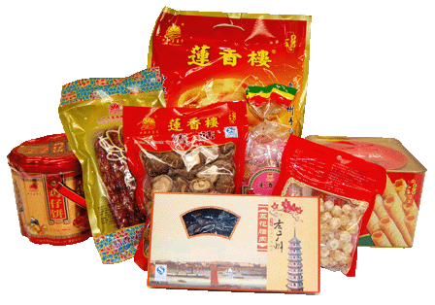 | GD10CN2 (內地派遞): $388  GD10HK2 (香港派遞): $488  GD10MO2 (澳門派遞): $488
 | 板鴨一袋(600克)、廣式臘腸一盒(500克)、五花臘肉一盒(500克)、雞仔餅一罐(500克)、蛋捲一罐(400克)、果仁酥糖一袋(300克)、糖蓮子一袋(200克)、香菇一袋(200克) | Preserved Duck (1 pack, 600g), Guangdong Style Preserved Meat Sausages (1 box, 500g), Preserved Pork Belly (1 box, 500g), Crispy Chicken Biscuits (1 tin, 500g), Egg Rolls (1 tin, 400g), Nutty Brittles (1 pack, 300g), Sweetened Lotus Seeds (1 pack, 200g), Dried Mushrooms (1 pack, 200g)
東方紅賀年禮品系列 (香港供應) / Gift sets provided by Tung Fong Hung (Supplied from HK)
大展鴻圖  Supreme Gift Set  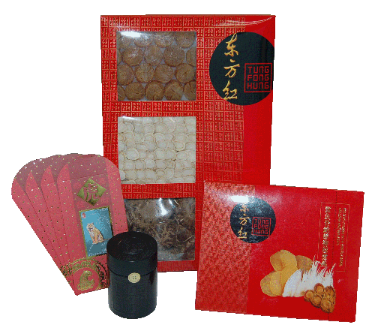 | HK10CN3 (內地派遞): $438  HK10HK3 (香港派遞): $418  HK10MO3 (澳門派遞): $438
 | 元貝4兩(150克)、花菇3兩(112.5克)、花旗參片(37.5克)、鯊魚骨鮑絲響螺燉雞1盒、珍藏普洱1罐、香港郵政虎年利是封一套 | Dried Scallop (150g), Dried Mushroom (112.5g) , American Ginseng Slices (37.5g), Stewed Chicken Soup with Shark Cartilage, Shredded Abalone and Conch (1 box), Pu’er Tea (1 can), Hongkong Post’s “Year of Tiger” Red Packets (1 pack)
金玉滿堂  Exquisite Gift Set  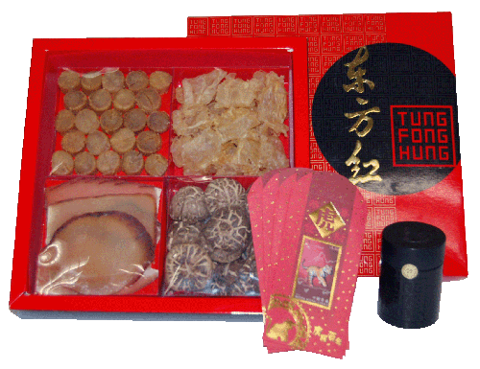 | HK10CN4 (內地派遞): $828  HK10HK4 (香港派遞): $798  HK10MO4 (澳門派遞): $828
 | 元貝6兩(225克)、花膠3兩(112.5克)、螺片3兩(112.5克)、花菇3兩(112.5克)、珍藏普洱1罐、香港郵政虎年利是封一套 | Dried Scallop (225g), Dried Fish Maws (112.5g), Dried Conch Slices (112.5g), Dried Mushroom (112.5g), Pu’er Tea (1 can), Hongkong Post’s “Year of Tiger” Red Packets (1 pack)
澳門商號賀年禮品系列(澳門供應) / Gift sets provided by Macao Post (Supplied from Macao)
大吉大利  Splendid Gift Set  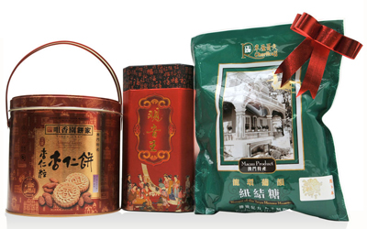 | GB_CN_10 (內地派遞): $258  GB_HK_10 (香港派遞): $258  GB_MO_10 (澳門派遞): $218
 | 咀香園杏仁粒杏仁餅(400克)、華聯鐵觀音王茶葉(250克)、R車厘哥夫脆卜米朱古力紐結糖 (220克) | Almond Cakes “Choi Heong Yuen” (400g), Ti Kuan Yin Tea “Va Lun” (250g), Rice Crispies Chocolate Nougat “R Cherikoff” (220g)
如意吉祥  Auspicious Gift Set  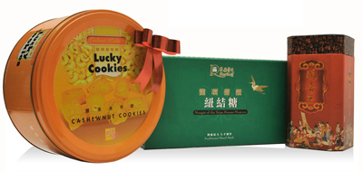 | GC_CN_10 (內地派遞): $378  GC_HK_10 (香港派遞): $378  GC_MO_10 (澳門派遞): $318
 | 樂宮腰果曲奇餅 (1000克)、華聯鐵觀音王茶葉(250克)、R車厘哥夫龍環葡韻紐結糖 (300克) | Cashew Nut Cookies “Lisboa Palace” (1000g), Ti Kuan Yin Tea “Va Lun” (250g), Nougat of the Taipa Houses Museum “R Cherikoff” (300g)

