Appendix 1

Exhibition for the 11th Inter-School Stamp Exhibits Competition
(14-16 May 2010)

To promote philately among students and to increase general interest in stamp collecting, the 11th Inter-School Stamp Exhibits Competition is organised by Hongkong Post, with the support from Education Bureau as the co-organiser.

An exhibition of winning entries and other stamp exhibits submitted will be held at Sky Dome Atrium, Discovery Park, Tsuen Wan, from 14 to 16 May. The admission is free and all are welcome. The opening hours of the Exhibition are:

14 May 2010 (Friday) | 12.00 noon – 7.00 p.m.
15 May 2010 (Saturday) | 11.00 a.m. – 7.00 p.m.
16 May 2010 (Sunday) | 11.00 a.m. – 5.00 p.m.

Apart from the displays of winning exhibits, the event will include exhibits demonstrations from philatelic societies. Guided tours and philatelic workshops will be conducted during the event. A sales booth with a variety of popular recent stamp issues will be available where customers can choose their favourite stamp products.

To mark the event, Hongkong Post will issue a souvenir cover together with a special postmark and a cachet. A hand-back date-stamping service for souvenir covers as well as privately-made covers bearing an indication of the event and a local address will be provided at the exhibition venue and at 37 philatelic offices on 14 May. Souvenir covers, priced at $2 each, will be put on sale at 37 philatelic offices from 3 to 14 May. Serviced souvenir covers at $5.9 each will be available for sale at the exhibition venue and at 37 philatelic offices on 14 May.
Sale Arrangement of Souvenir Cover

Information about the sales arrangements of philatelic products associated with the souvenir cover is as follows:
Product available from 3 May 2010 | Unit Selling Price | Restriction Per Queuing Customer
Souvenir Cover  (only available at the exhibition venue and 37 philatelic offices) | $2 | No restriction

Product available on 14 May 2010 | Unit Selling Price | Restriction Per Queuing Customer
Serviced Souvenir Cover affixed with a $1.4 definitive stamp, date-stamped with special postmark and cachet  (only available at the exhibition venue and 37 philatelic offices on 14 May 2010) | $5.9 | Five Covers

Date-stamping Arrangements

A hand-back date-stamping service by the office steel date-stamp, the “Philatelic Bureau” pictorial postmark, the philatelic office pictorial postmark and the special postmark will be provided on 14 May 2010 at the exhibition venue and 37 philatelic offices for souvenir covers as well as privately made covers bearing an indication of the event and a local address. However, the GPO-1 date-stamp will be only available at the General Post Office. A cachet will be available for application on covers from 14 to 16 May 2010 at the exhibition venue throughout the exhibition period and 37 philatelic offices during normal office hours.

Public hall of the Hongkong Post Philatelic Bureau will be opened from
9.30 a.m. to 5.00 p.m. on 14 May 2010 to provide date-stamping service by the “Philatelic Bureau” pictorial postmark and the special postmark.

Information about this exhibition and the souvenir covers may be obtained from the website of Hongkong Post at www.hongkongpost.com, at any post offices or by calling the Hongkong Post Philatelic Bureau hotline on 2785 5711.

Images of the Special Postmark, Cachet and Souvenir Cover

Images of the Special Postmark, Cachet and Souvenir Cover are reproduced below:
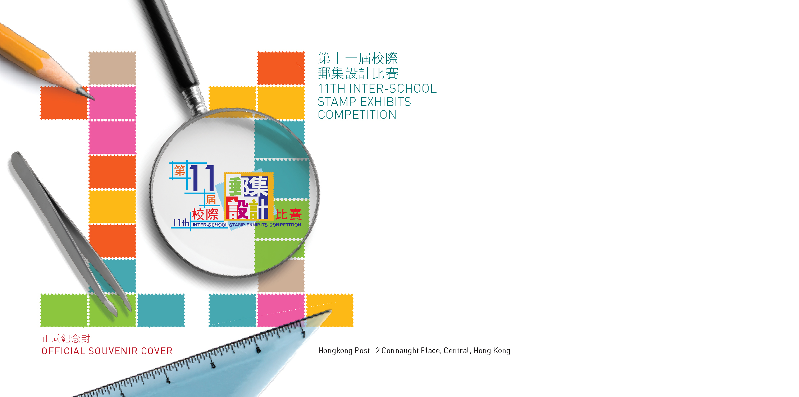

Souvenir Cover

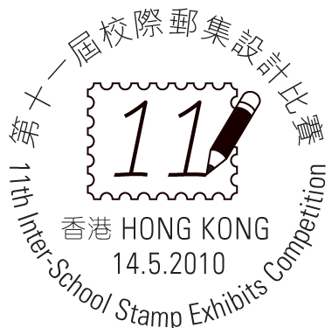
Special Postmark

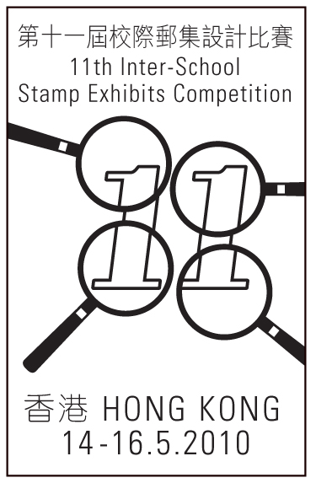
Cachet

